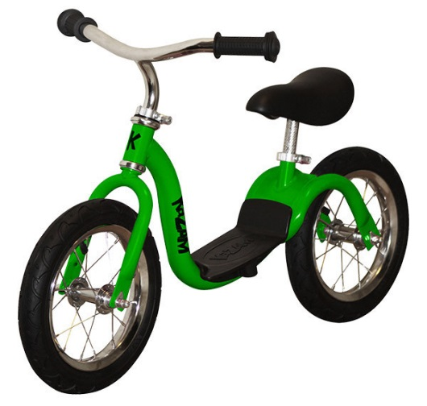
Balance Bikes in the garden
You have been developing your skills when using the balance bikes at nursery. You are able to glide on the balance bike with control. You negotiate your pathway by stopping or avoiding obstacles. You follow instructions and use the traffic light system to go, get your bike ready or stop. You are able to use motorway (fast) and low bridge (slow) techniques to glide on the bike.

