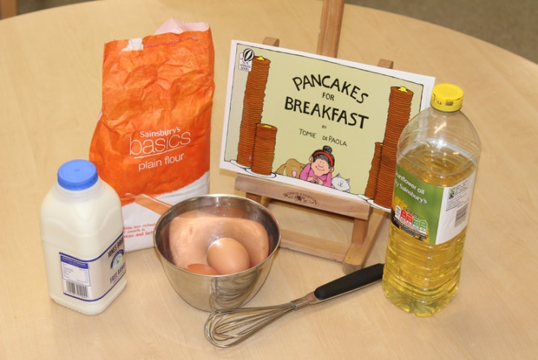
Courgette Pancakes
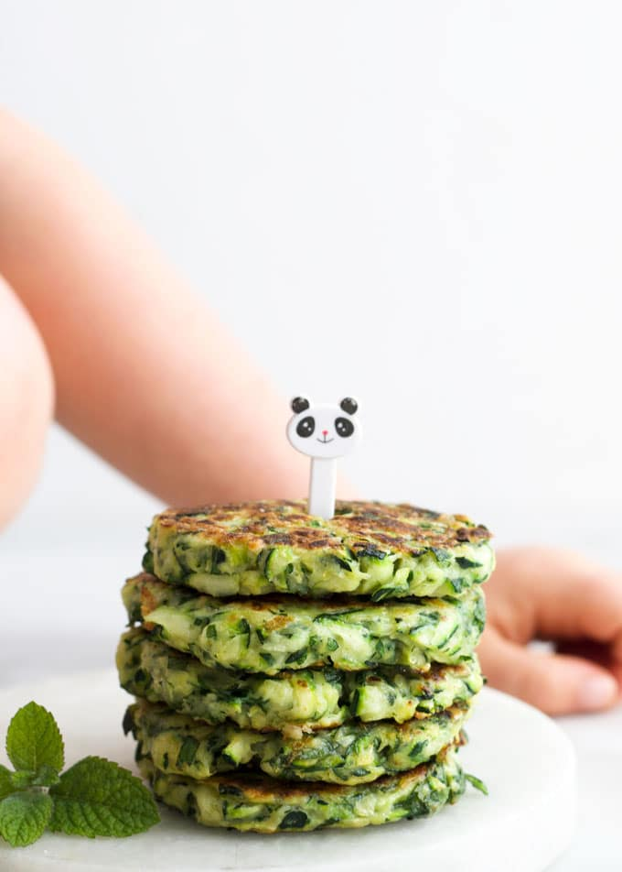
Ingredients
50g plain flour
2 eggs
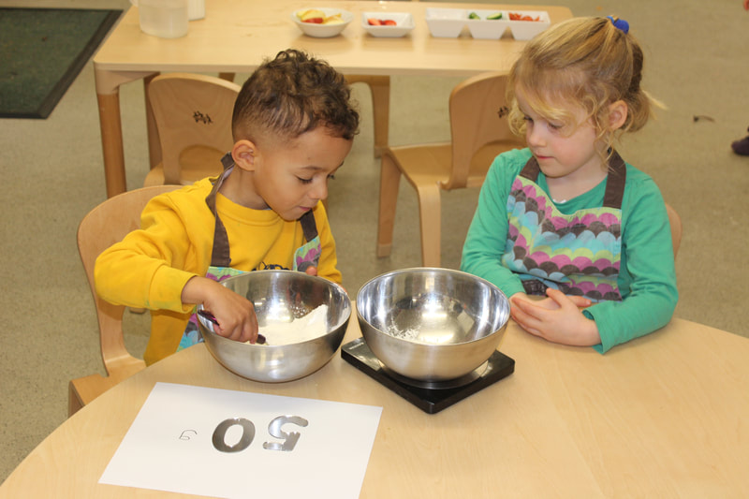
50ml milk
1 courgette, grated
1 tbsp oil

Method
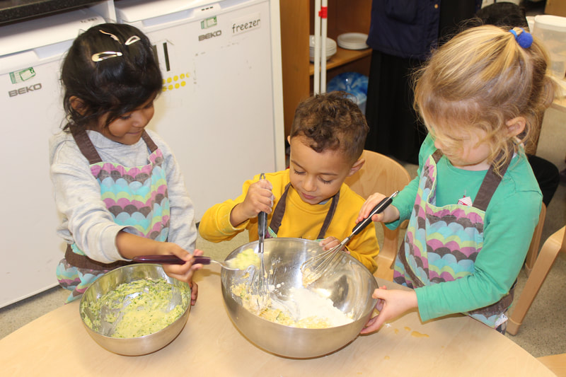
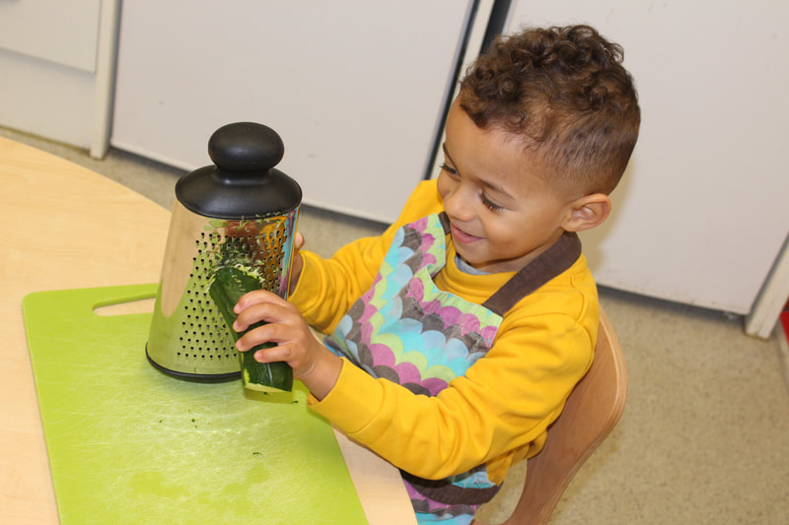
Tip flour into a bowl. Make a well in the centre, break in eggs, then gradually whisk together, adding milk, a little at a time, to make a smooth batter. Stir in courgette and season well. Heat oil in a non-stick frying pan. Add tablespoons of mixture to make pancakes, and cook for 2-3 mins on each side until lightly golden.
