Recipe for Shortbread Biscuits

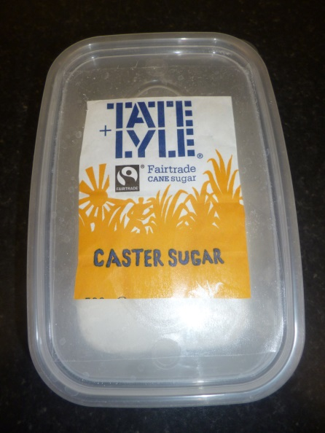
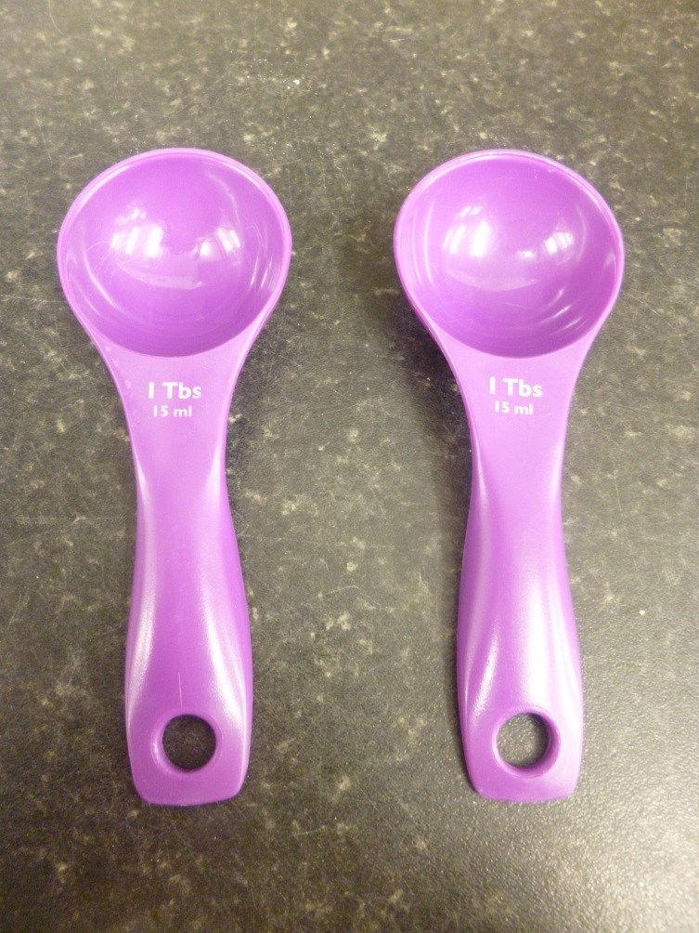
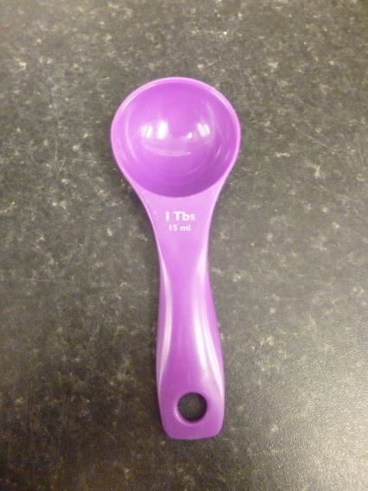
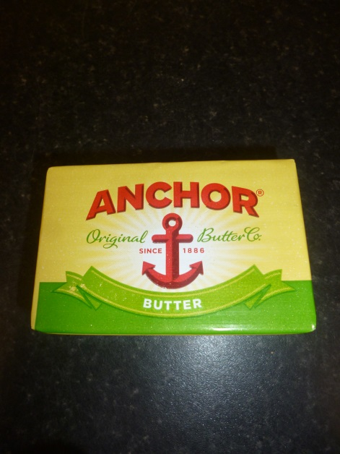
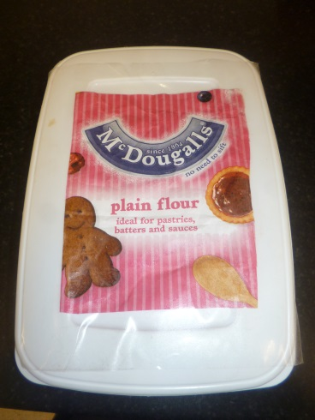
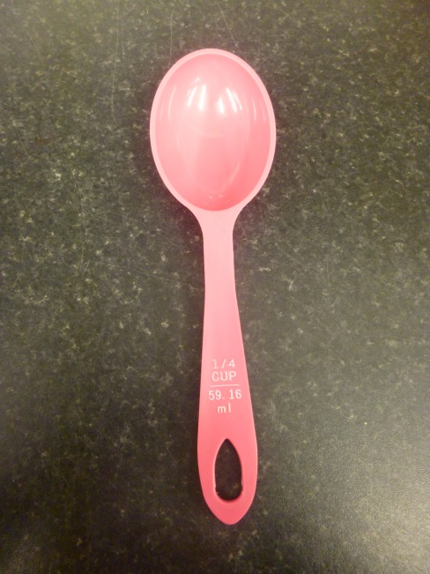
Oven should be pre-heated to 175 (please ask adult to assist you)
Once all the ingredients have been measured and added to your bowl, please use your fingers to crumble the ingredients together.
Mix your crumbled ingredients into a ball of dough.
Form 4 equal sized biscuits and place onto your baking tray.

