Singing at nursery and home: Music is like magic to children
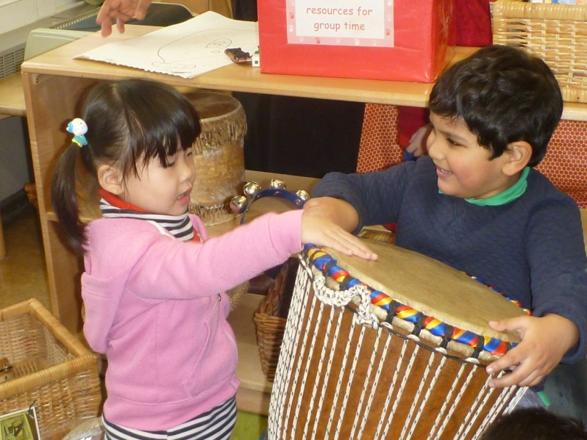

Nursery Rhymes

Baa Baa Black Sheep
Baa baa black sheep, have you any wool?
Yes sir, yes sir, three bags full!
One for the master, one for the dame,
And one for the little boy who lives down the lane.

Incy Wincy Spider
Incy Wincy spider climbing up the spout
Down came the rain and washed the spider out
Out came the sunshine and dried up all the rain
And Incy Wincy spider climbed up the spout again.
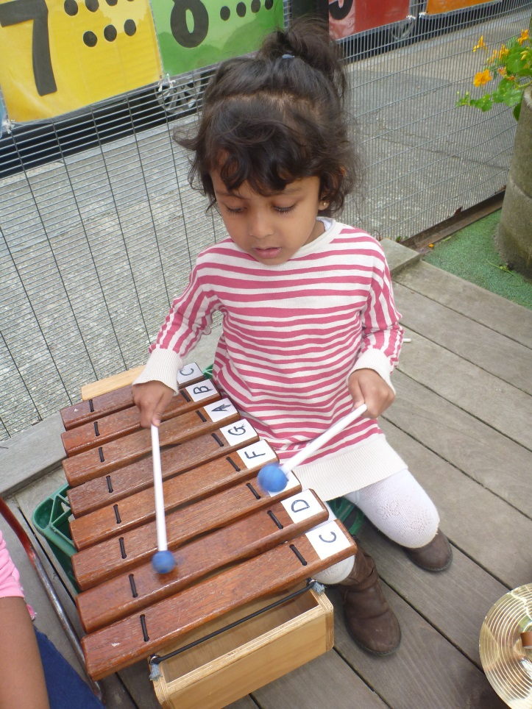

Hey Diddle Diddle
Hey diddle diddle, the cat and the fiddle,
The cow jumped over the moon.
The little dog laughed to see such fun
And the dish ran away with the spoon!

Hickory Dickory Dock
Hickory Dickory Dock
The mouse ran up the clock
The clock struck one
The mouse ran down
Hickory Dickory Dock.

Mary had a little lamb
Mary had a little lamb,
It's fleece was white as snow;
And everywhere that Mary went
The lamb was sure to go.
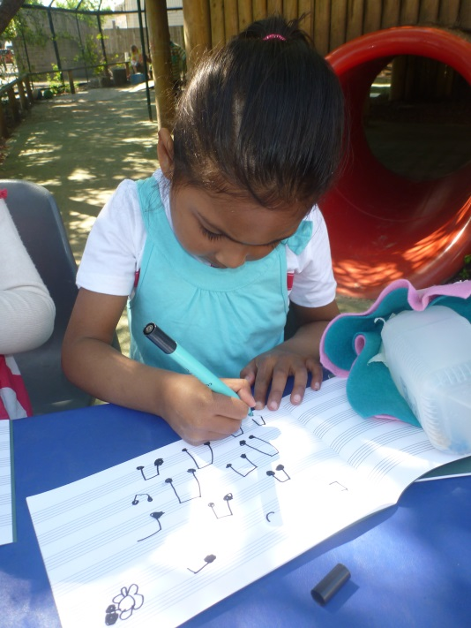

Jack and Jill went up the hill
Jack and Jill went up the hill
To fetch a pail of water.
Jack fell down and broke his crown,
And Jill came tumbling after.

Action Songs

Head, shoulders, knees and toes
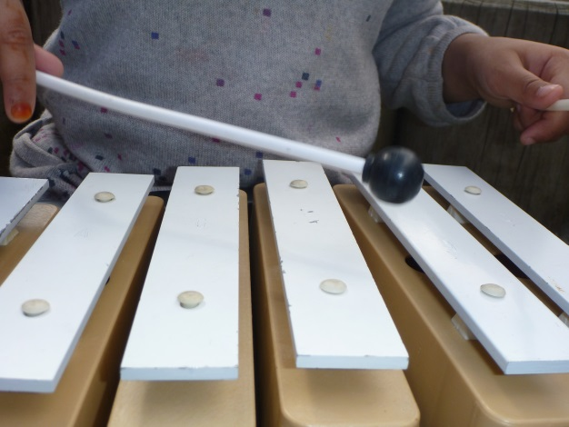
Head, shoulders, knees and toes, knees and toes
Head, shoulders, knees and toes, knees and toes
And eyes and ears and mouth and nose
Head, shoulders, knees and toes, knees and toes.

Ring-a-ring o' roses
Ring-a-ring o' roses,
A pocket full of posies,
A-tishoo! A-tishoo!
We all fall down.

The Wheels on the Bus
The wheels on the bus go round and round,
round and round,
round and round.
The wheels on the bus go round and round,
all day long
The wipers on the bus go Swish, swish, swish;
Swish, swish, swish;
Swish, swish, swish.
The wipers on the bus go Swish, swish, swish,
all day long
The horn on the bus go Beep, beep, beep;
Beep, beep, beep;
Beep, beep, beep.
The horn on the bus go Beep, beep, beep,
all day long.

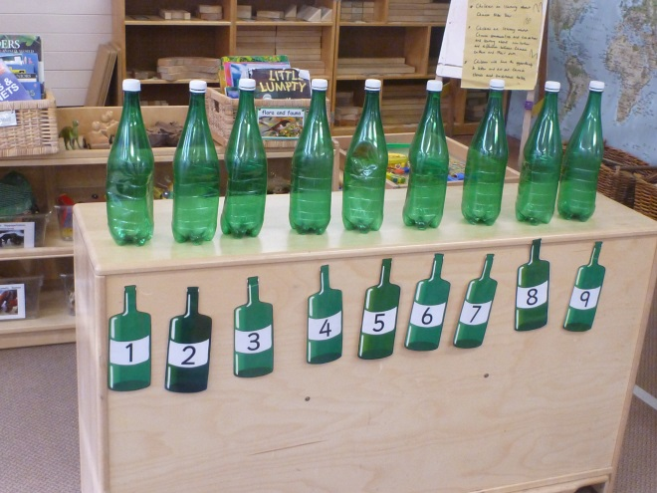
Number Songs

Five Currant Buns
Five currant buns in a baker's shop.
Big and round with a cherry on the top,
Along came a boy with a penny one day,
Bought a currant bun and took it away.
Four currant buns in a baker's shop.
Big and round with a cherry on the top,
Along came a boy with a penny one day,
Bought a currant bun and took it away.
Three currant buns in a baker's shop.
Big and round with a cherry on the top,
Along came a boy with a penny one day,
Bought a currant bun and took it away.
Two currant buns in a baker's shop.
Big and round with a cherry on the top,
Along came a boy with a penny one day,
Bought a currant bun and took it away.
One currant bun in a baker's shop.
Big and round with a cherry on the top,
Along came a boy with a penny one day,
Bought the currant bun and took it away.
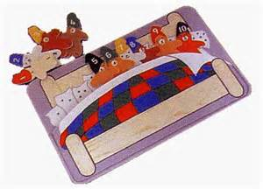

Ten in the Bed
There were ten in the bed
And the little one said,
"Roll over! Roll over!"
So they all rolled over
And one fell out

Ten green bottles
Ten green bottles sitting on the wall,
Ten green bottles sitting on the wall,
And if one green bottle should accidentally fall,
There'll be nine green bottles sitting on the wall.

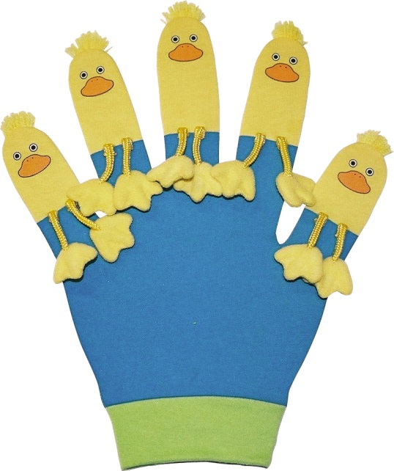

Five little ducks
Five little ducks went swimming one day
Over the hill and far away
Mother duck said, “Quack quack quack quack”
And only four little ducks came back!

Five little speckled frogs
Five little speckled frogs,
Sat on a speckled log,
Eating some most delicious bugs.
Yum yum!
One jumped into the pool,
Where it was nice and cool,
Then there were four speckled frogs.
Glub glub!
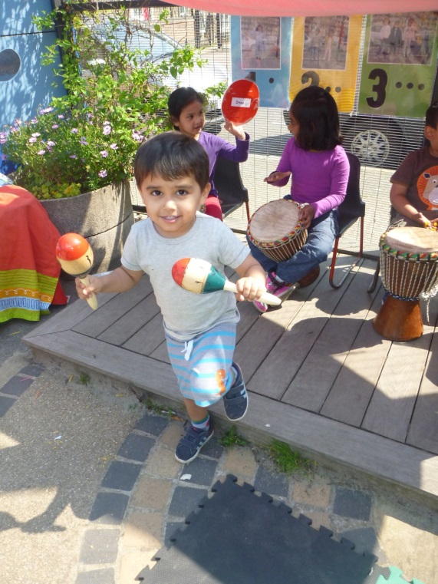

Five little monkeys
Five little monkeys jumping on the bed,
One fell off and bumped his head.
Mother called the doctor and the doctor said,
"No more monkeys jumping on the bed!'.

