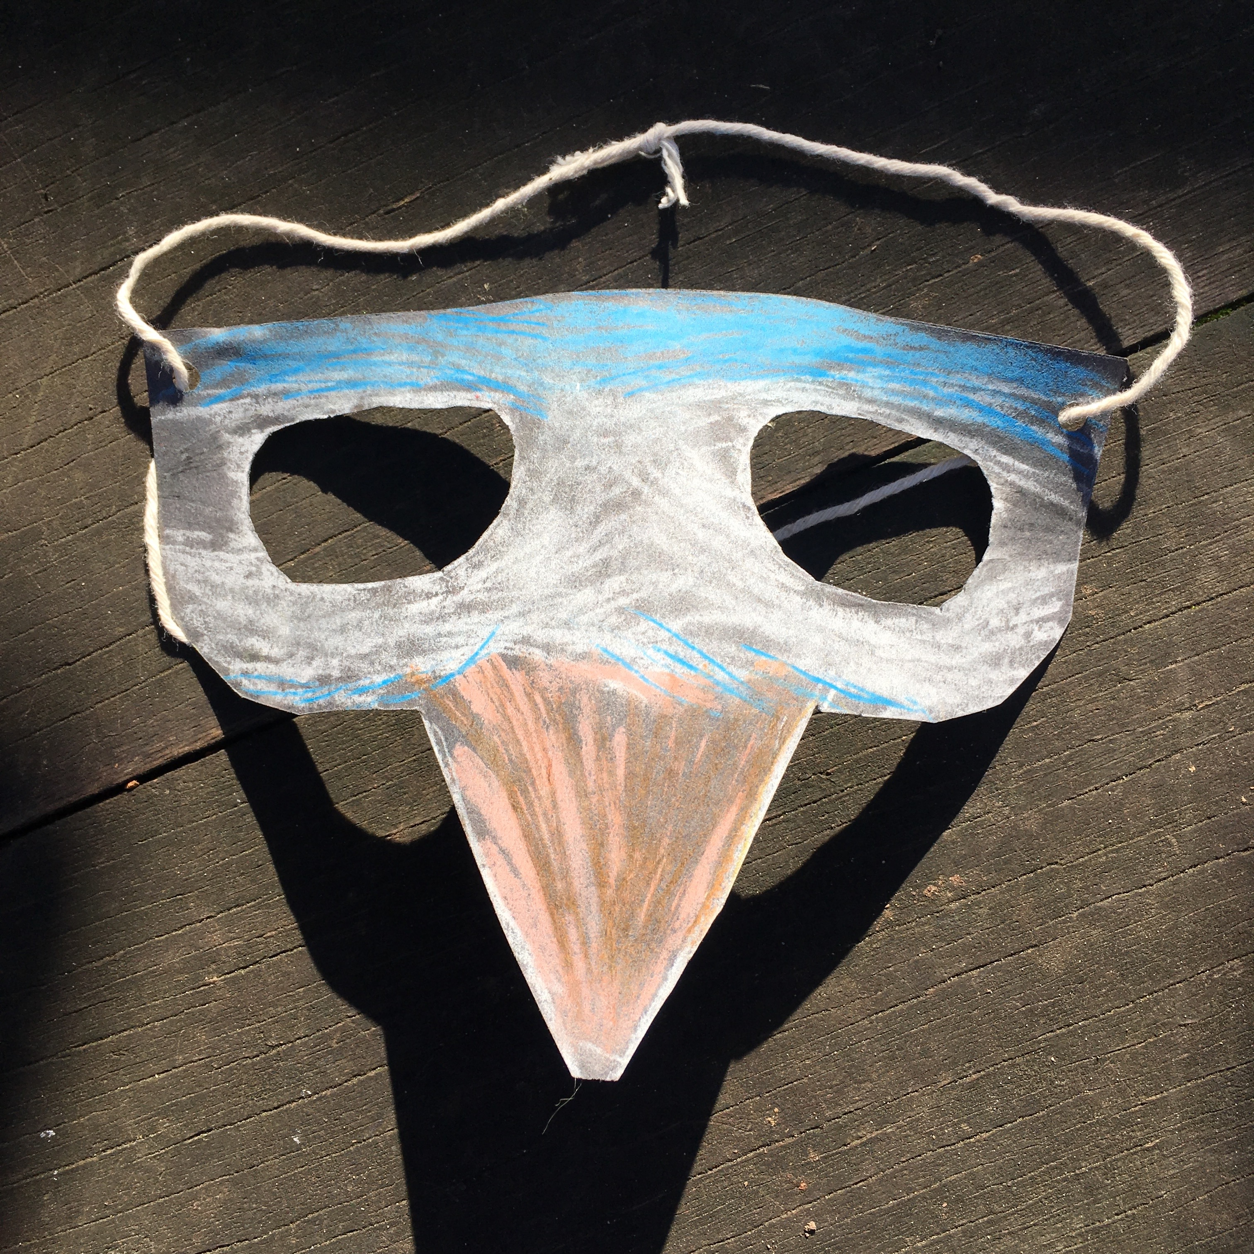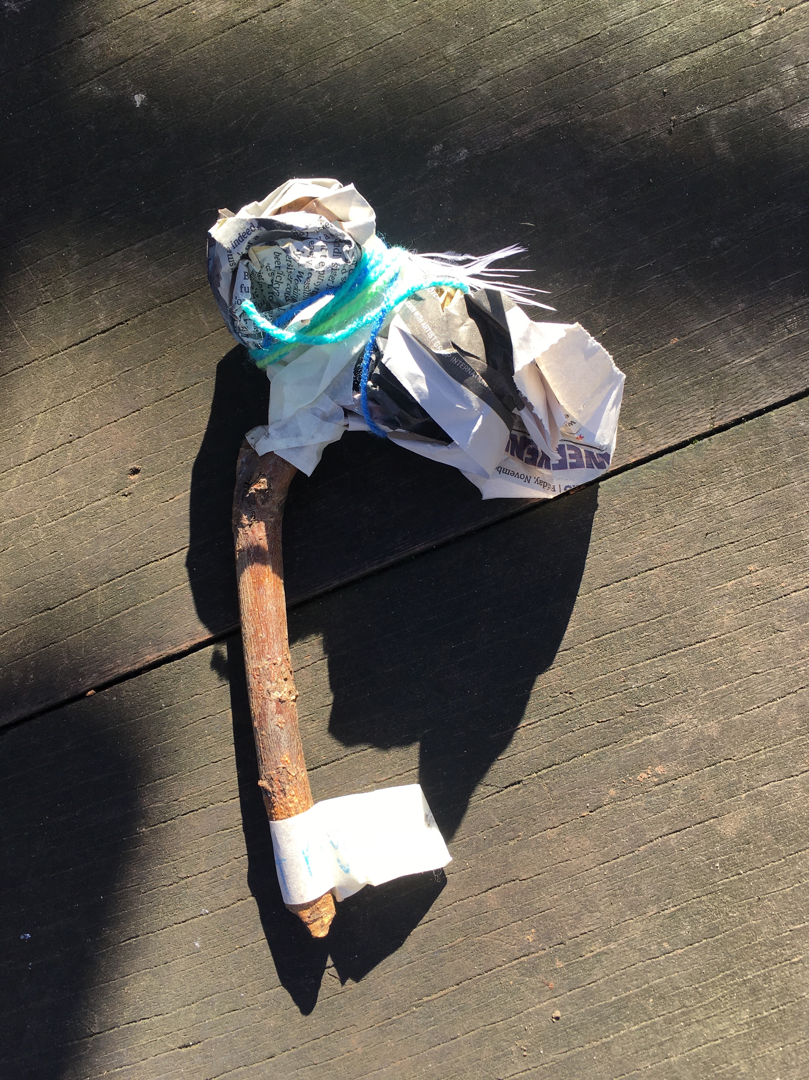

play mask

Draw the character you want to make

Think about if it has horns, ears, beak, tusks……

Fold the card in half vertically to cut the mask shape

Fold the mask in half vertically again to cut the eye holes

Cut yarn to size of wearer’s head

Make holes for string in the top corners of the mask

Please supervise inexperienced makers.

Use your health and safety skills to use tools safely.

You will need card, scissors, yarn, chalks, paint, glitter, glue

story puppet

Scrunch a page of paper into a body shaped ball

Bind it with sticky tape onto a twig

Decorate with whatever colourful yarn, raffia, fabric scraps, wrapping tie, feathers you have saved for a rainy day

Paint to suit

If you have made a person add a costume

Please supervise inexperienced makers.

Use your health and safety skills to use tools safely.

You will need

fabric scraps, feathers, silver foil, paint recycled paper, sticky tape, a twig,