Independent Project – Dolls House

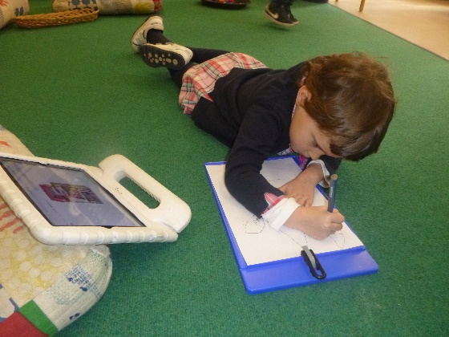
From a conversation with a friend, you were inspired to make your own dolls house. You shared that you didn’t have a house for your dolls and thought about how you would like your dolls house to look.
You used the IPad to research different dolls house and used some of these images to draw up a plan for your own model.
I was very impressed with the way you labelled your plan. From your plan I am able easily able to read that your dolls house will have 3 floors – bedroom on top, kitchen in the middle and bathroom on the ground floor. You decided on the different colours you would decorate it and also identified the different materials and tools you will require.
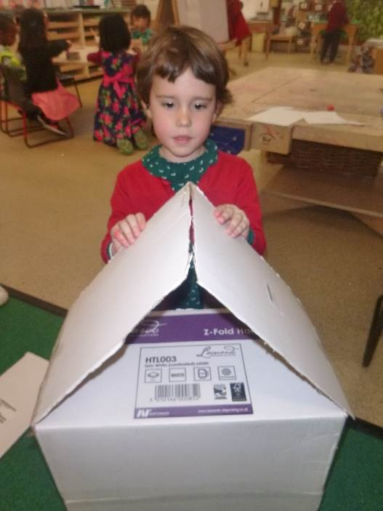
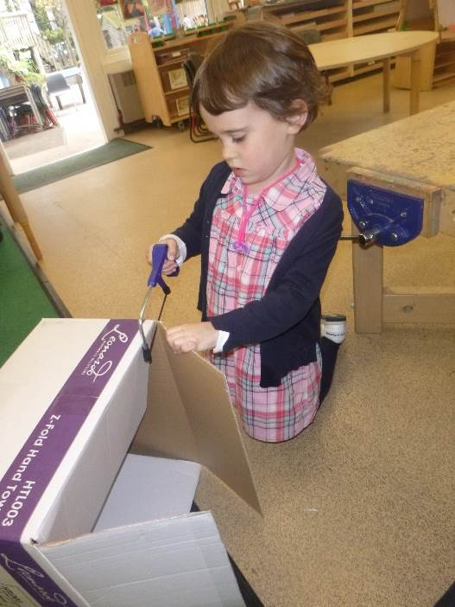
You chose a large cardboard box to form the outside of your house and you used a range of one-handed tools to get the perfect shape.

You were able to do all this with very little adult support. Well done!

You had a friend help you with painting your dolls house. You then shared you have a balcony at home and would like to make a balcony for your dolls house. You drew a door on the roof and used a knife to cut it out. You then problem solved and created a balcony using lolly sticks.
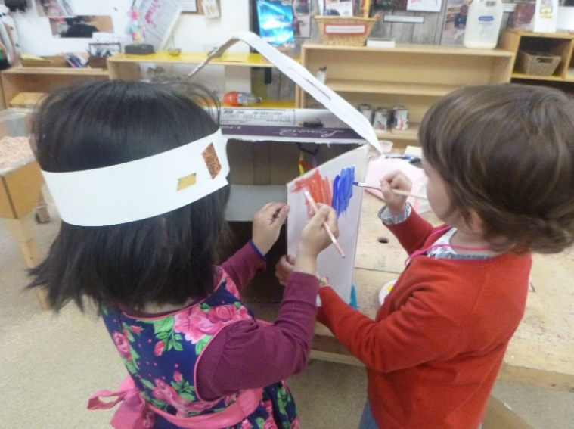
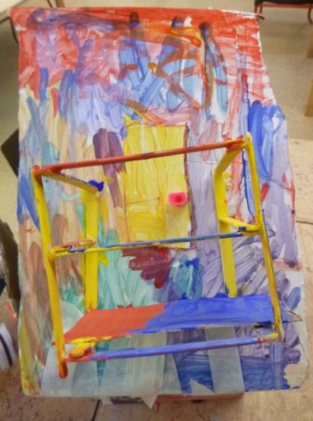

It looks amazing!

You worked really hard on your project and showed great persistence and problem solving skills. You returned to work on it every day and the end result is fantastic! Good job!
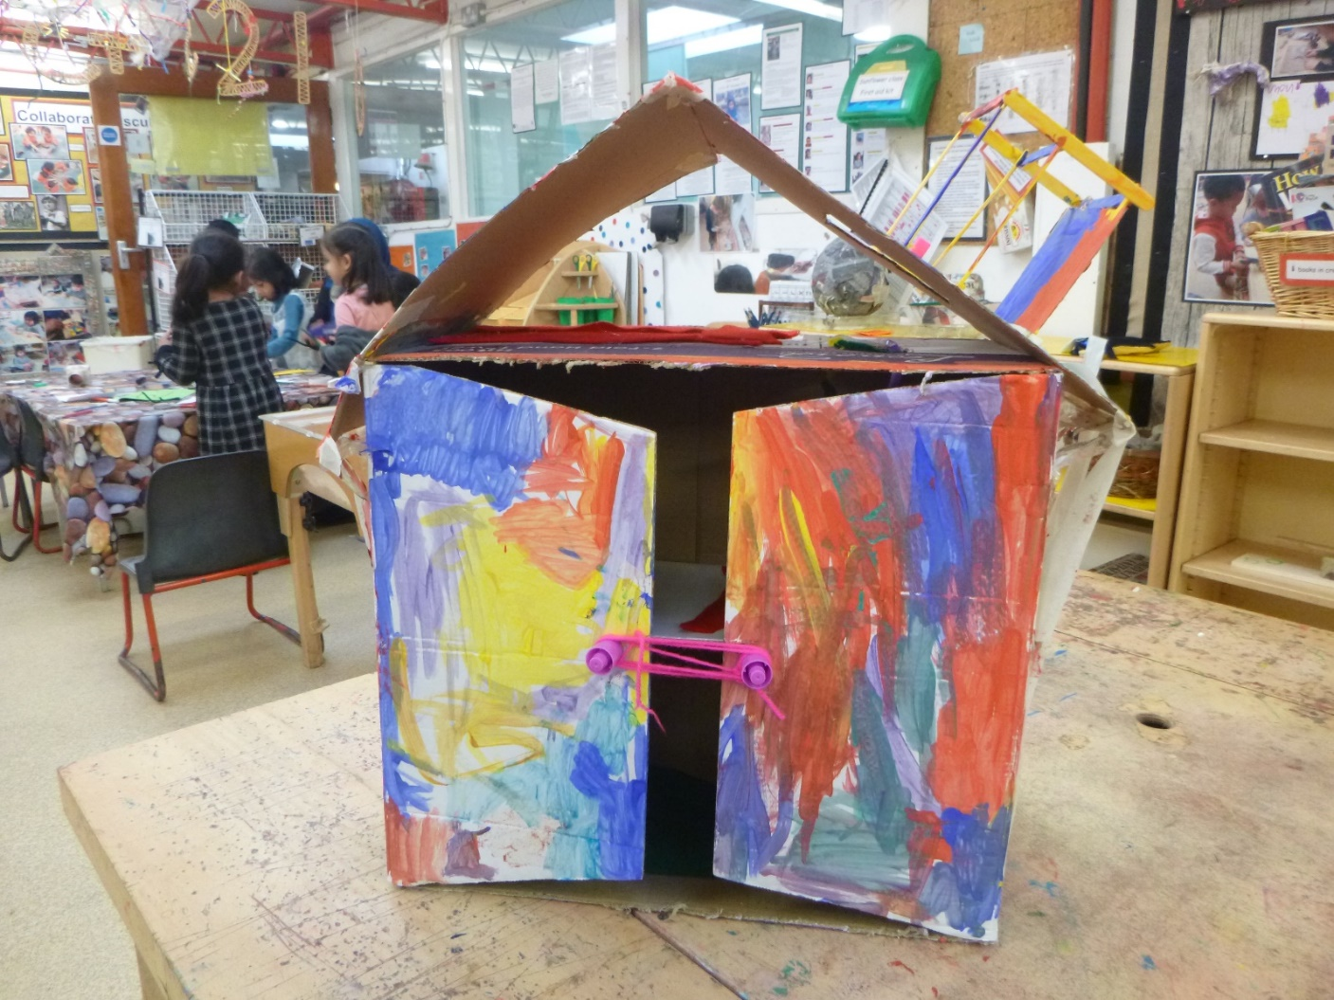

Can you draw what your dolls house looked like when you finished and match it with your plan to see if it looks the same?

