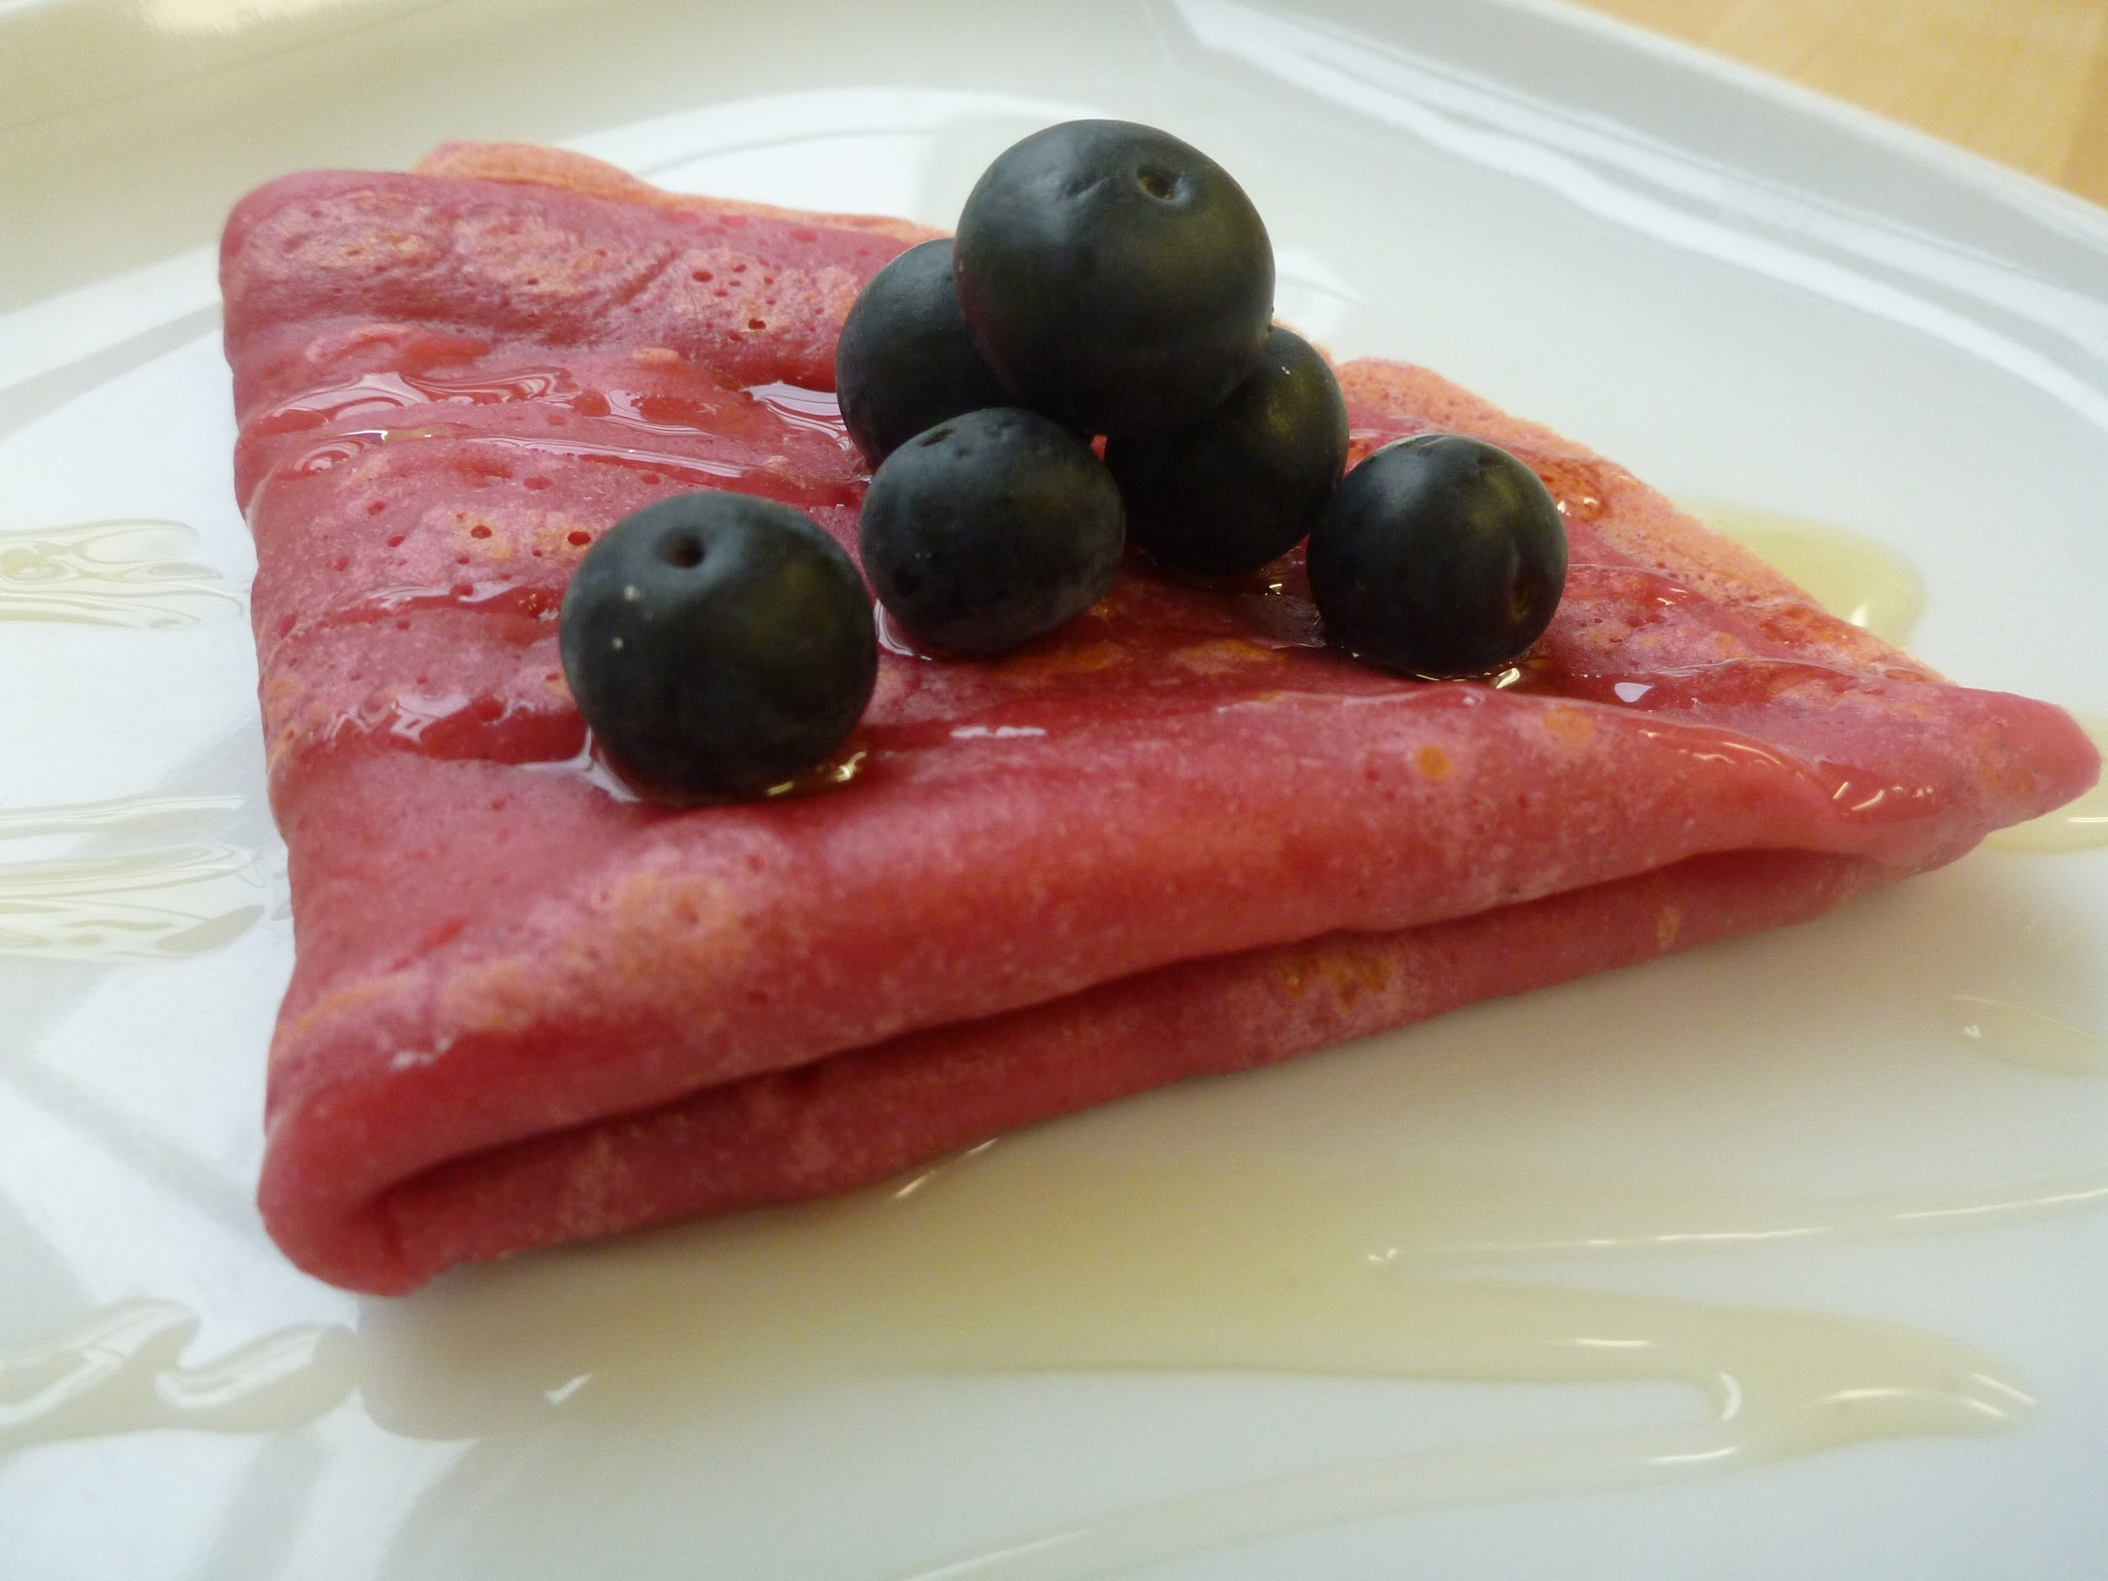
Beet Pancake
You Will Need:
- 1 cup of all-purpose flour
- ¾ cup of whole-wheat flour
- 1 tablespoon of brown sugar
- 1 tablespoon of baking powder
- ¾ cup of beet puree
- ¼ cups milk
- 1 cup of plain Greek yogurt
- 1 egg
- 3 tablespoons of unsalted butter, melted butter
- 1 teaspoon of vanilla essence
How To:
- In a bowl, sift whole wheat flour, all-purpose flour, sugar and baking powder
- In another bowl, add beet puree, milk, egg, butter, Greek yogurt and vanilla and mix well.
- Add the dry ingredients to the wet ingredients and stir until well combined.
- Grease a frying pan with oil and drop two tablespoons of pancake mixture into it.
- Cook the pancake for 3 minutes and flip. Cook for another 3 minutes and serve with honey.

