**Communication and Language Development**

**Communication and Language at Rachel Keeling is about the following:**

* Promoting children's enjoyment of books, literature and speaking and listening.
* Developing children's early writing skills through meaningful and relevant experiences.
* Using language to articulate thinking.
* 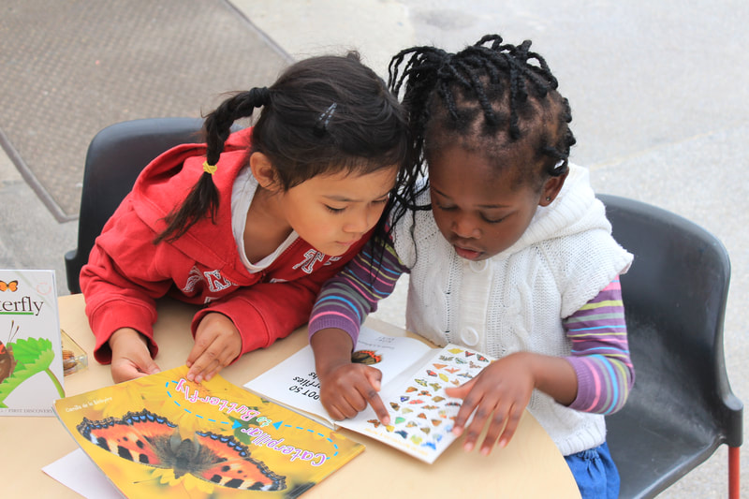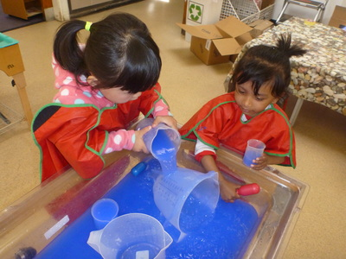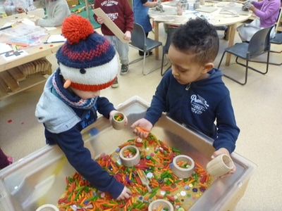Fostering an enjoyment of rhyme and alliteration.

