Expressive Arts and Design

Expressive Arts and Design at Rachel Keeling is about the following:
- Providing high quality creative experiences for children to foster both their cognitive and creative skills.
- Providing experiences where children work with a range of media including clay, paint, wood and music and dance.
- Promoting imaginative play as a means of not only enabling children to make sense of their world but also to develop their own imagination.
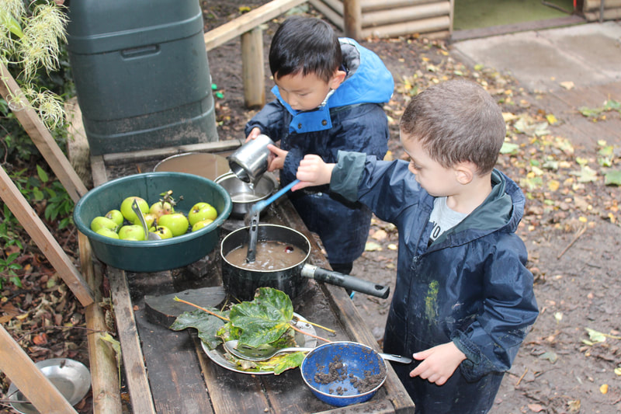
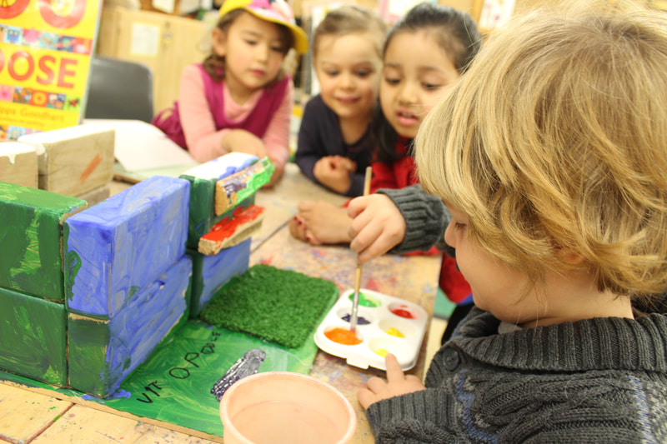
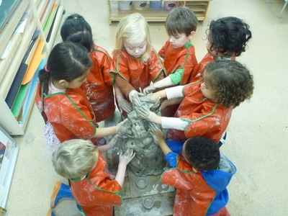
- Recognising that creativity is important in nurturing children's expressive and cognitive skills.
