Independent Project – Bag

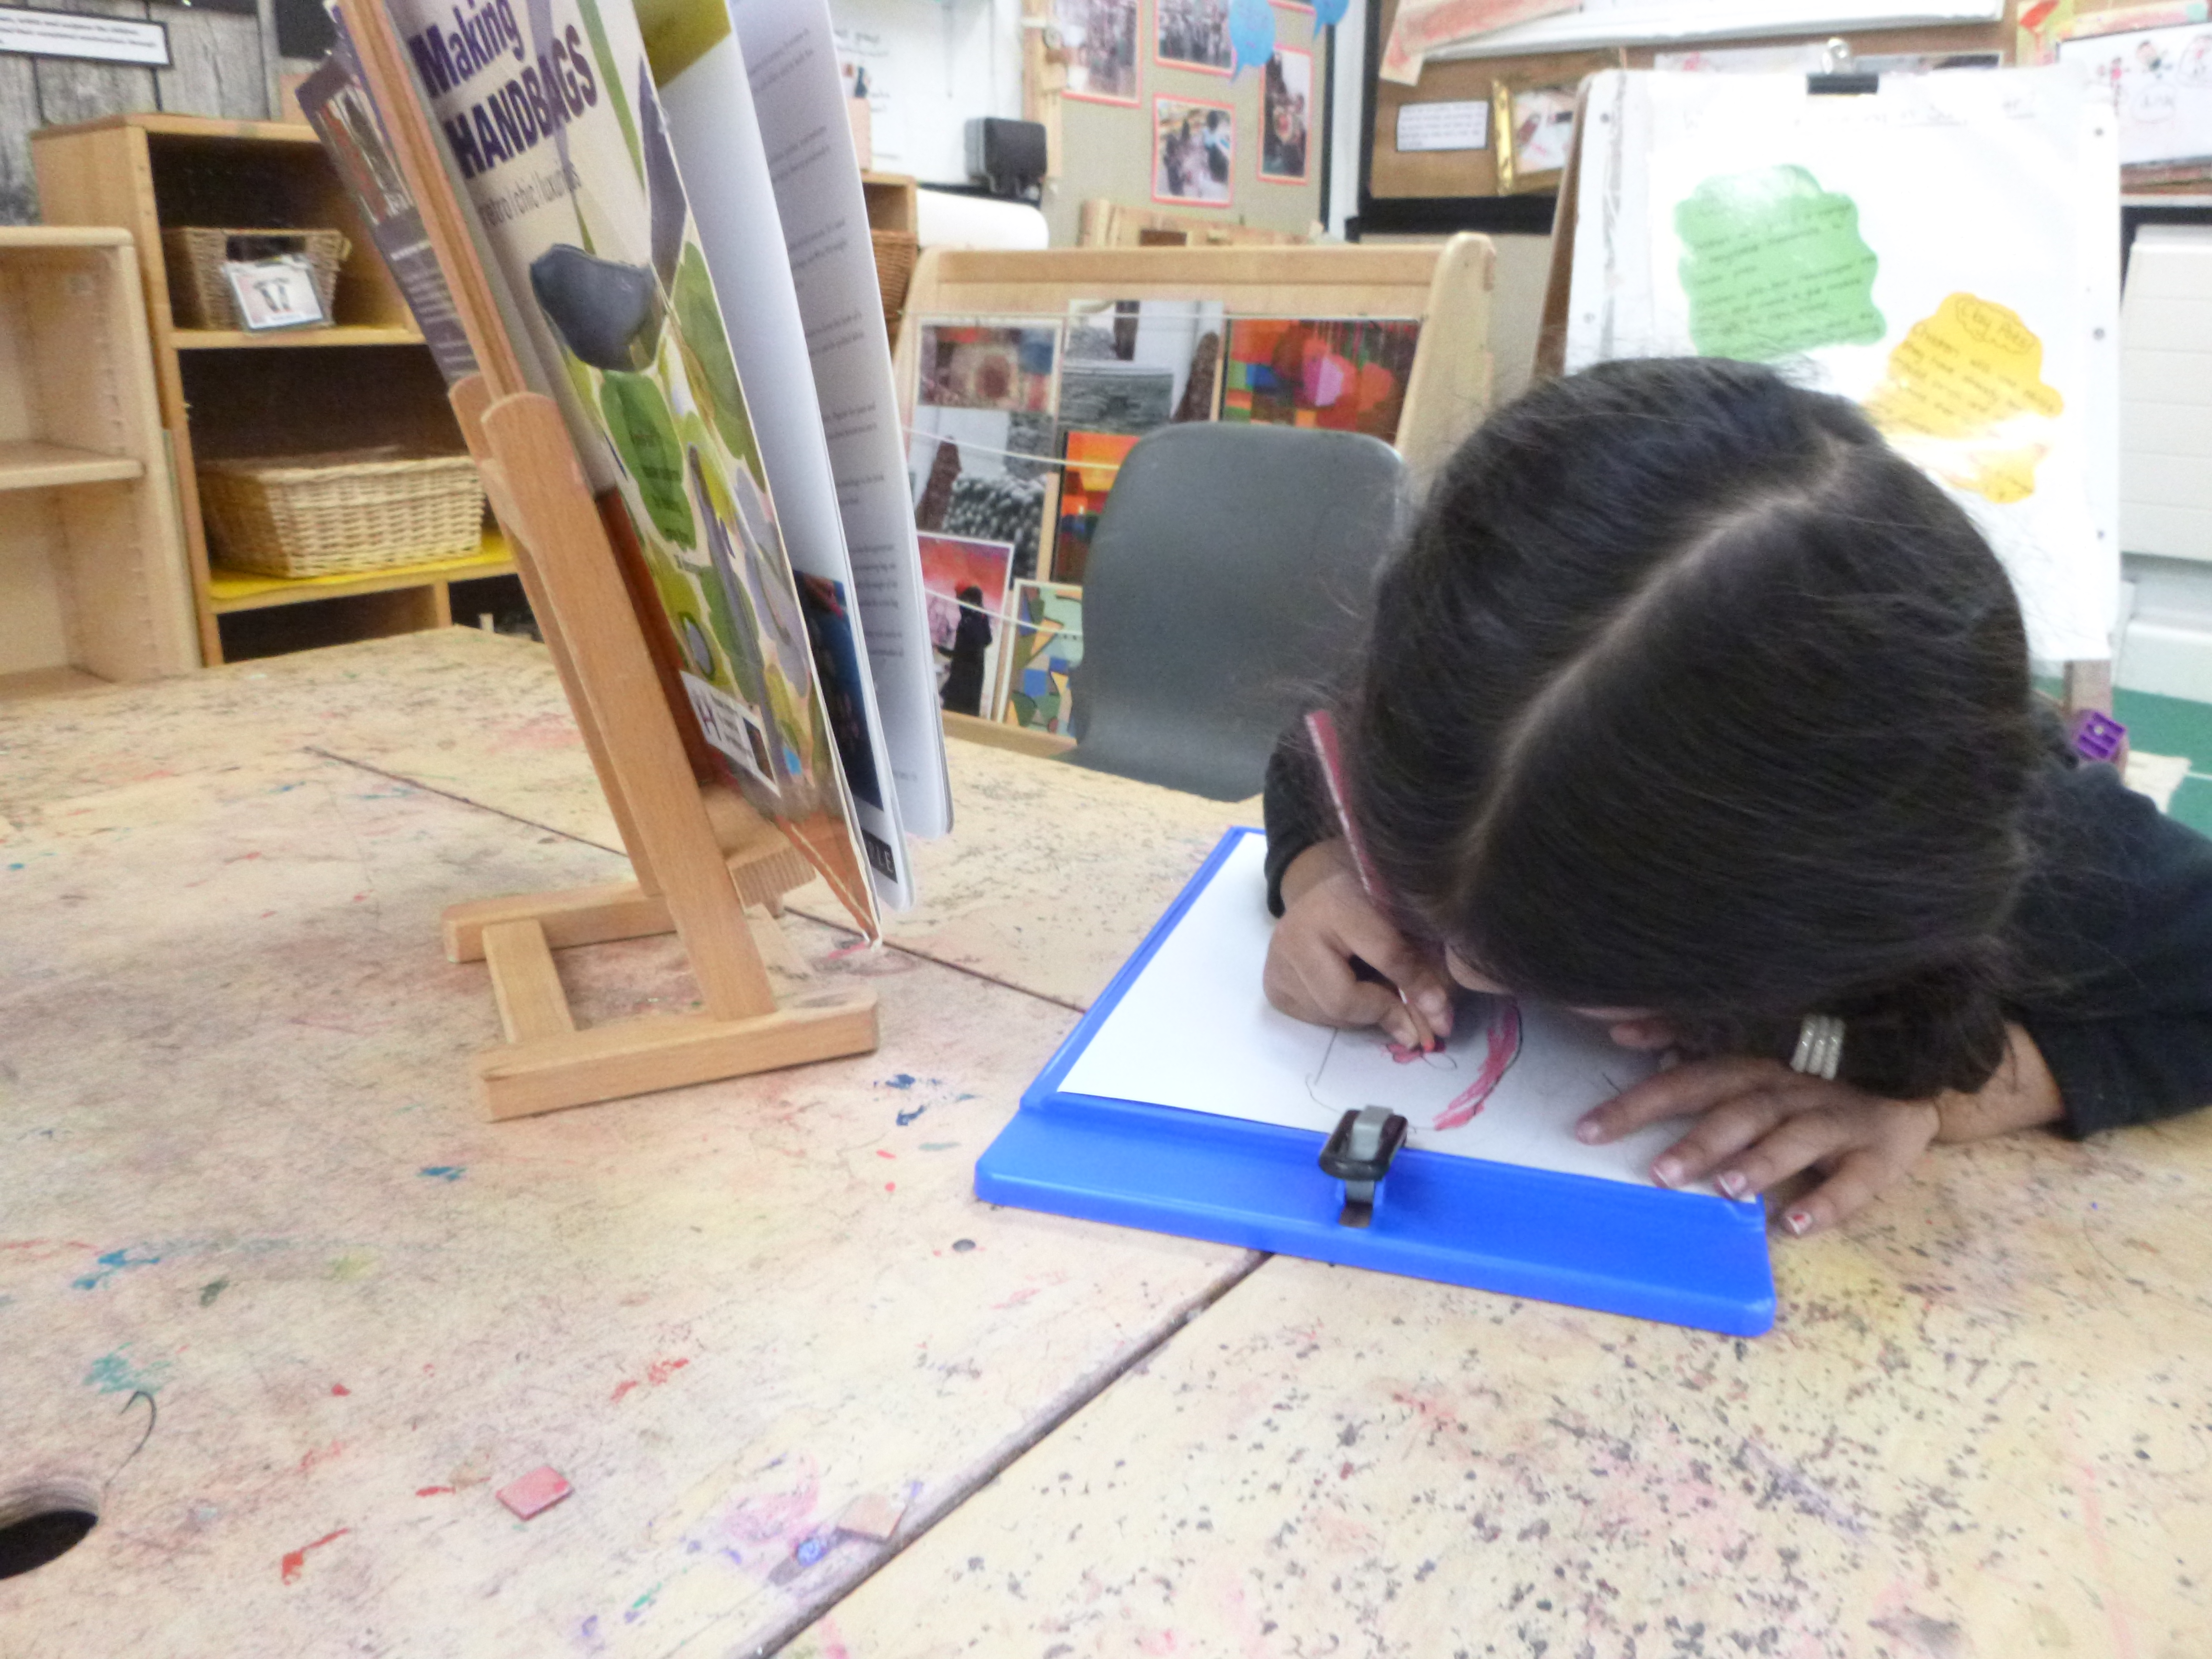
I set you a challenge to plan, design and create anything of your choice and you did a fantastic job!
You were inspired by a book on handbags and decided to make a bag of your own. You used the book to gather ideas and draw up a plan. You chose your different colours and also decided what tools you would need.
You were able to label your plan by scribing some words phonetically.

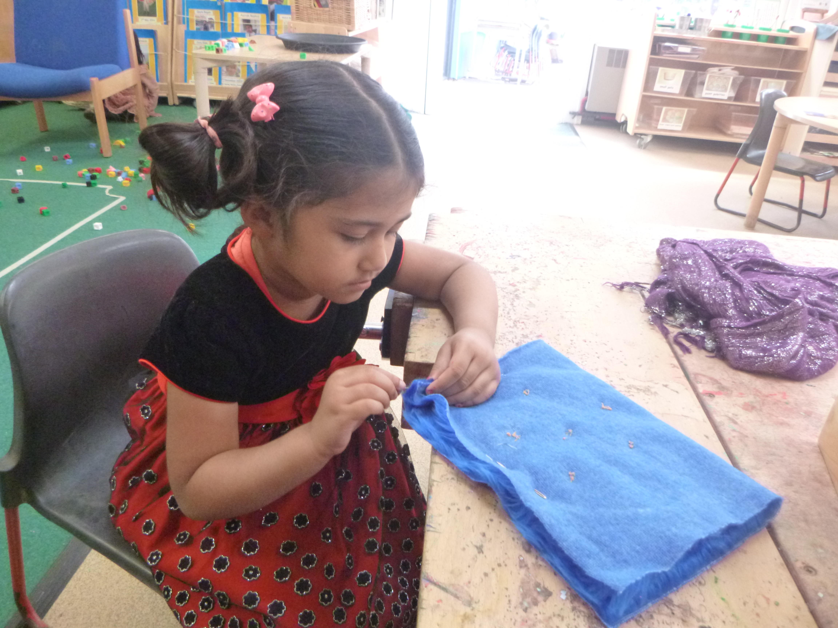

Firstly you searched for blue fabric to form the sack part of your bag. You chose a lovely, fluffy fabric. You cut it to your size, folded it in half and used a thread and needle to sew the 2 sides together.

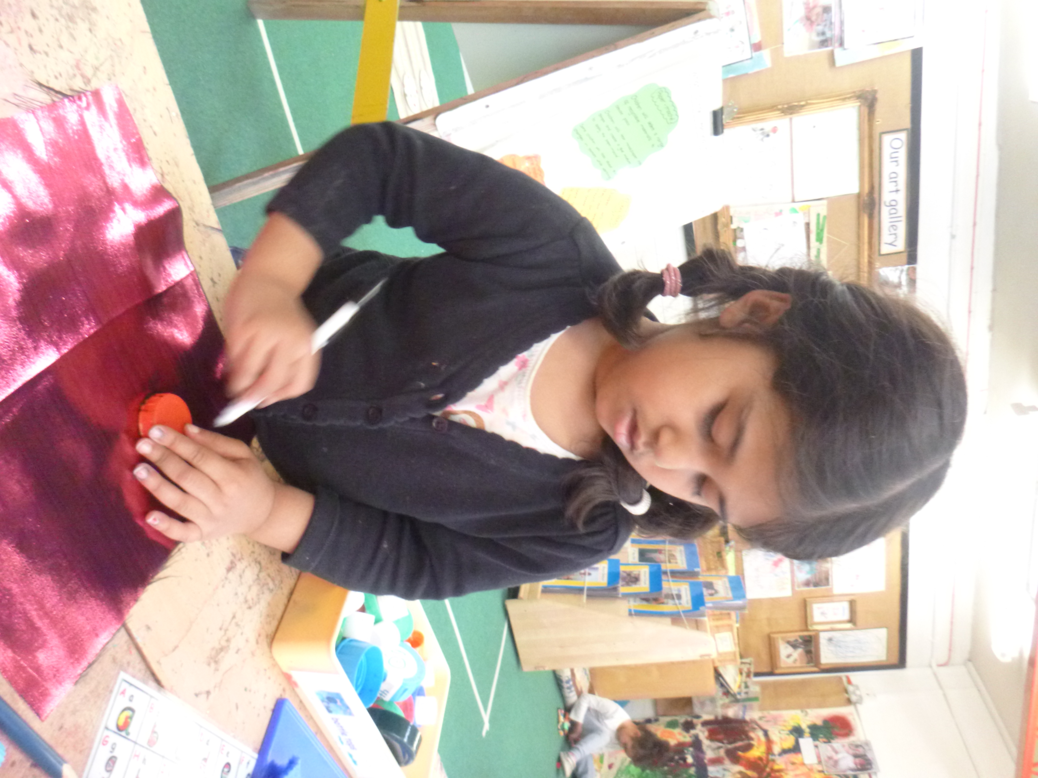

Next you selected a pink, shiny fabric to create the flower motif on the front of your bag. Your petal shape was going to be in circles so you used a bottle lid to draw around to form equal shapes. You then cut them out carefully and arranged the beautifully on your bag.

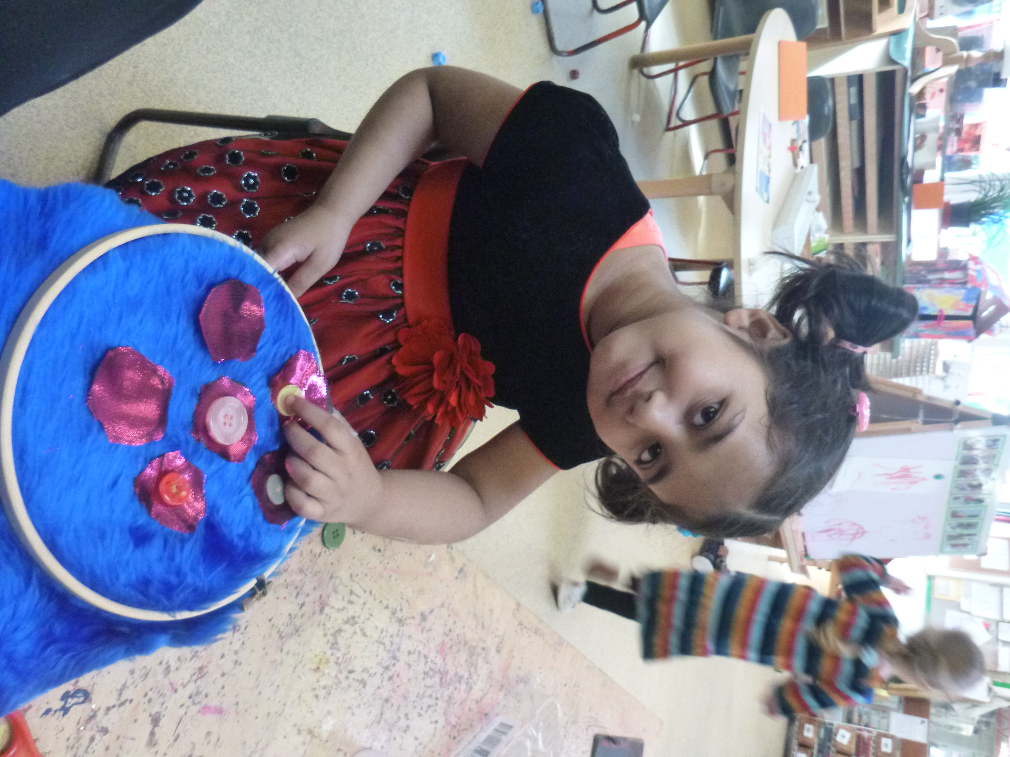

Then came a problem. The pink fabric was too slippery and wouldn’t hold a stitch. We thought very hard and decided to sew on a button on each petal to hold it in place. It worked! The end result – beautiful!

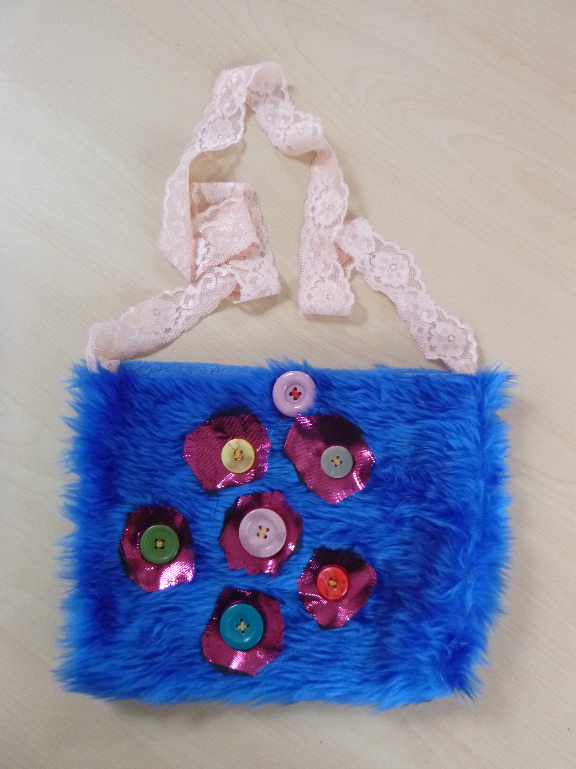

Lastly, you chose a lovely piece of lace to use as the handle. You sewed this on and also sewed on button your help keep your bag closed.

Can you draw a picture of how your bag looked when you finished and compare with your initial plan Does it look the same?

