Literacy

Our children are exposed to rich, exciting and challenging literature which extends their reading, writing and phonological understanding. Children develop their literacy skills using a range of strategies including:
- writing about real and relevant experiences
- practitioners scribing children's text
- sharing real books
- re-telling familiar stories
- engaging with parents/carers to share stories/books at home
- Practitioners using aspirational vocabulary in meaningful contexts
- making their own books
- educational visits
- writing for a range of purposes; stories, poems, shopping lists, post cards, labels
- targeted story sessions
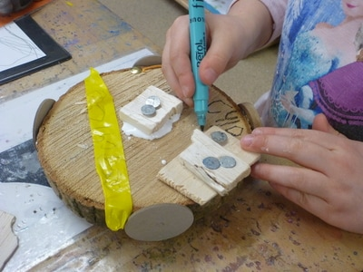
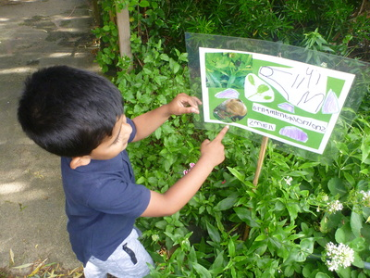
- acting out and narrating stories
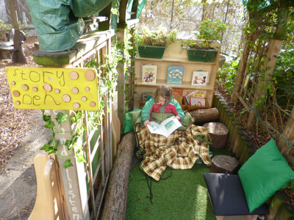
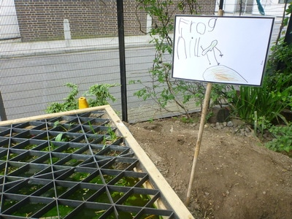
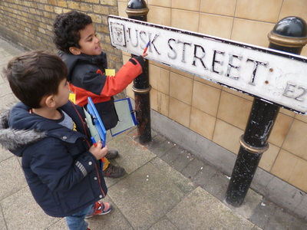
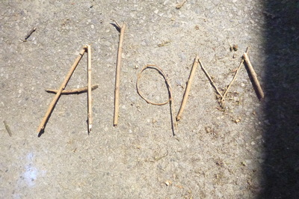
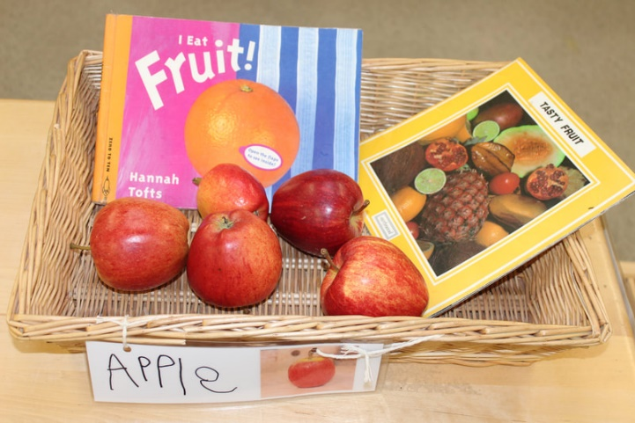
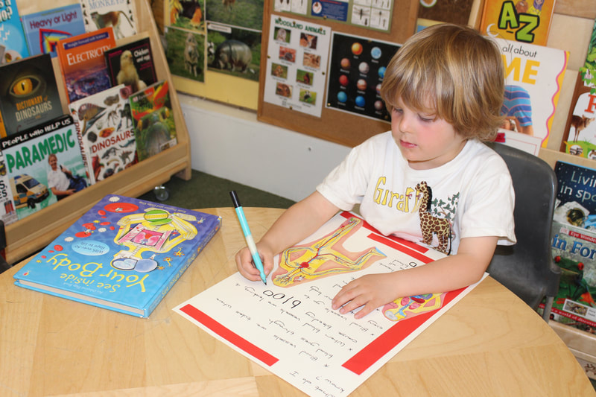
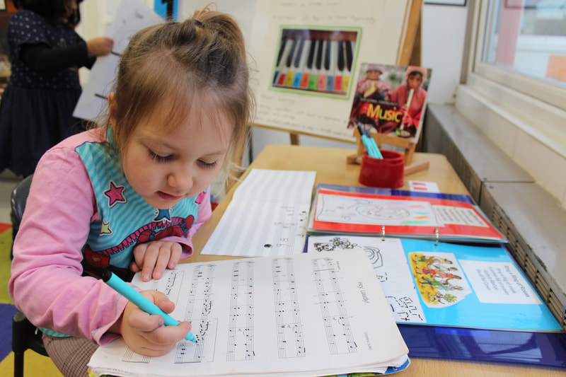
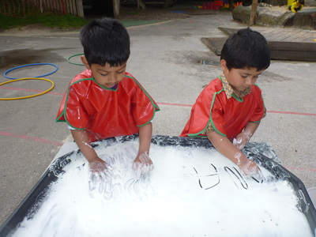
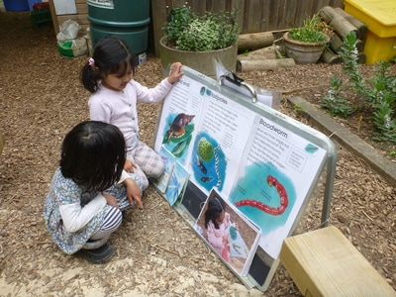
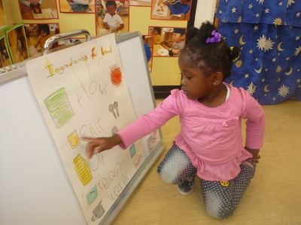
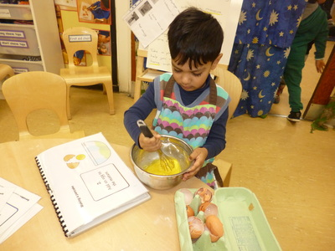
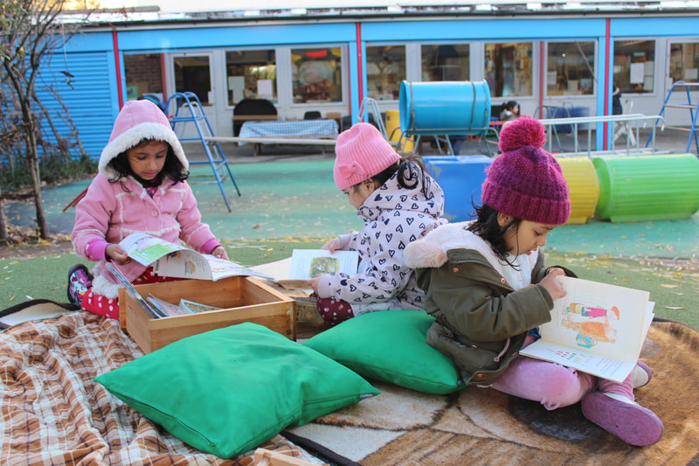

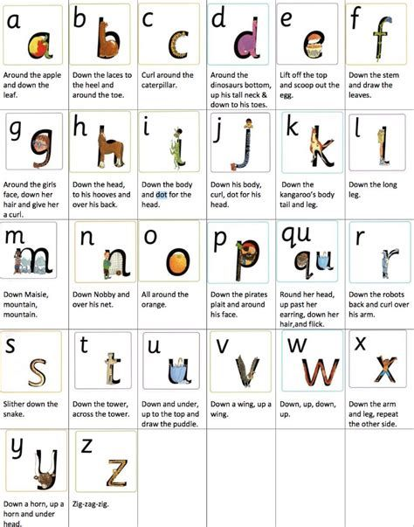
Phonics
Support children using initial letter sounds, blending and segmenting where appropriate within a meaningful context.
Provide opportunities for children to listen and contribute to rhymes and poems, exploring words and meaning. We use the Letters and Sounds approach in story sessions, alongside Ruth Miskin Read Write Inc resources to develop a consistent approach to teaching letters and sounds.

