Mathematics
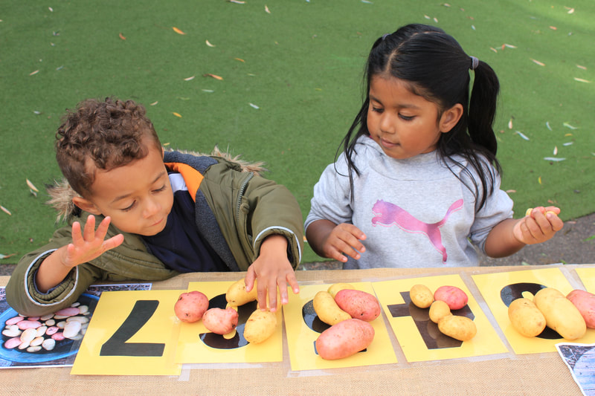
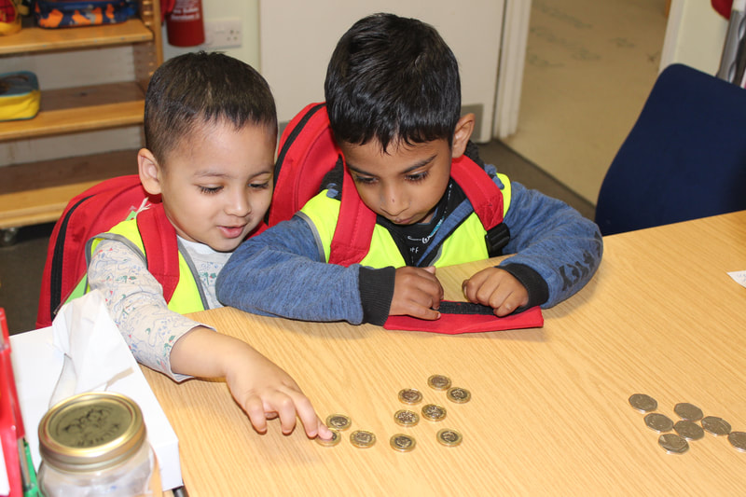

Mathematics at Rachel Keeling is about the following:
- Developing children's ability to recognise numbers.
- Developing children's ability in counting through meaningful and relevant experiences.
- Fostering an interest in solving simple calculations, such as subtraction and addition.
- Developing children's ability to recognise and know some properties of two dimensional and three dimensional shapes.
​​There are loads of fun and easy things you can try to help your child to explore numbers, giving them a great start to developing early numeracy skills and concepts.
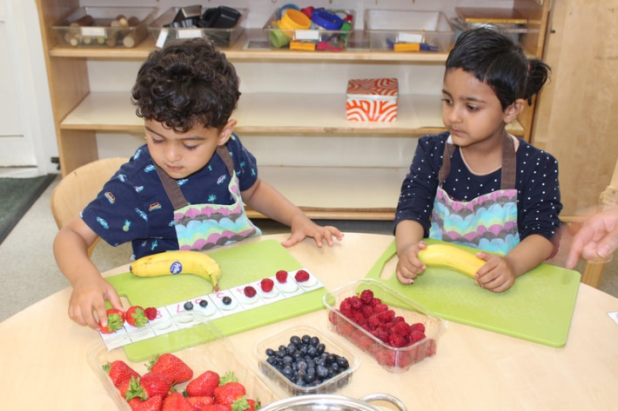
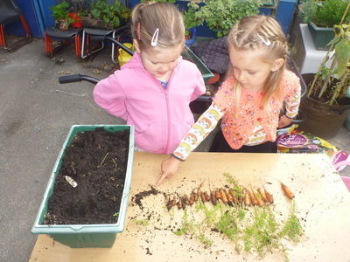
1. Count everyday objects together
Bringing numbers to life can be as easy as counting everyday items with your child. Start by counting small objects together: toys, fruit, or crayons will work. Only count one type of object at a time – note that this is more effective if the object is fun or enticing to them!

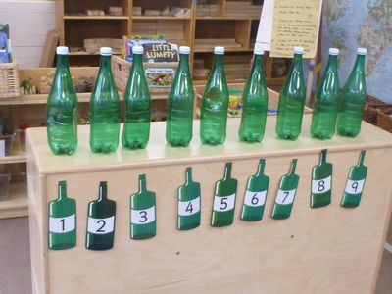
2. Sing counting songs
Many nursery rhymes are designed to help children to count. Counting songs like Ten Green Bottles or Five Little Ducks progress in reverse order, which can be especially helpful when young children start thinking about adding and taking away.
Using fingers as counters can be a useful way to make a visual link between numbers and quantity.

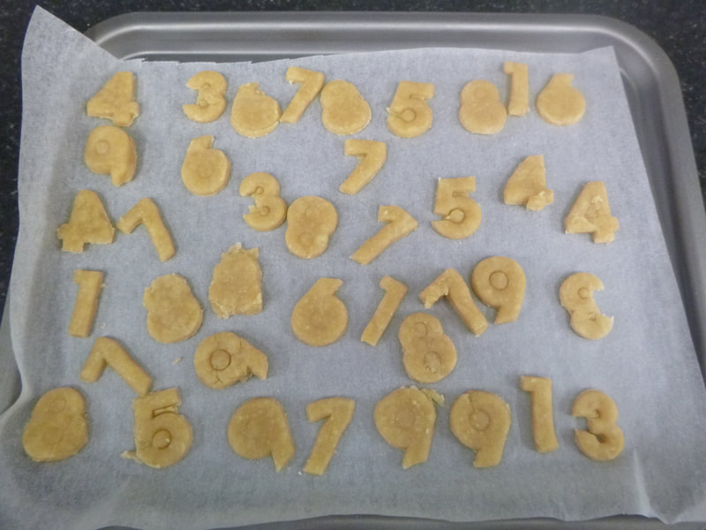
3. Build, draw, and write numbers together
Help your child to learn the numerals by engaging with their shapes. You can start by making numbers out of modelling clay: try an important date, their age, or your house number. From there, you can start drawing numbers together for fun activities.

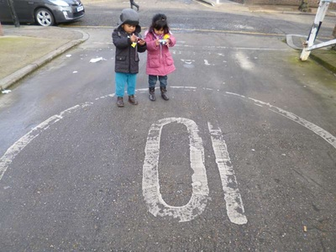
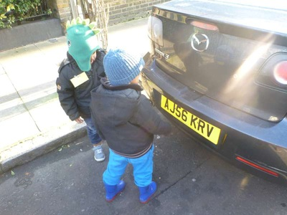
4. Point out numbers when out and about
We are surrounded by numbers wherever we go: try pointing out numbers when you see them! Learning to recognise the shapes of numbers is as important as knowing how to count out loud, and introducing these symbols early will do wonders down the road.
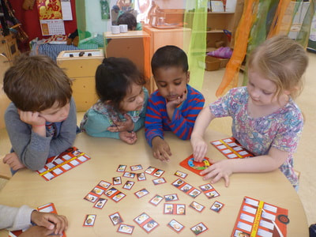
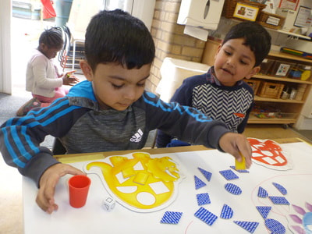
​5. Play board games together
As well as being a great way to spend family time, many children’s board games can help with counting. Games using dice provide a great opportunity to count and add up numbers together. Snakes and ladders can have children counting from about 20 all the way up to 100, depending on the size of the board.
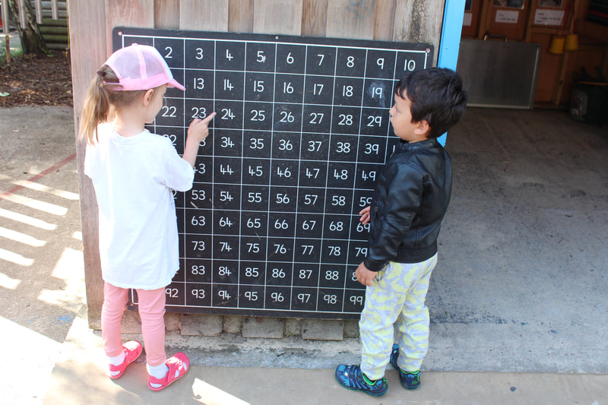
Play a board game with a dice, counting the spots on the dice and moving along the board. (To make this more challenging, add an extra dice, roll both and count the total number of spots)
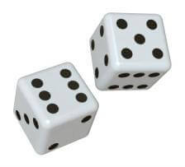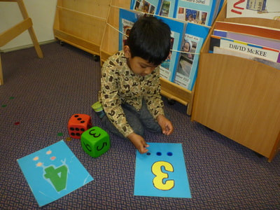

6. Read counting books
There are many stimulating picture books with stories based around numbers that you can enjoy with your child.
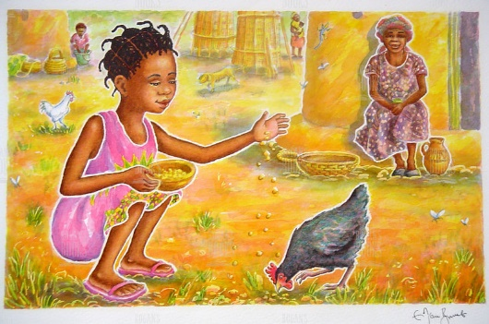
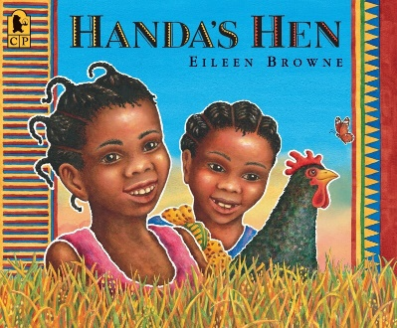
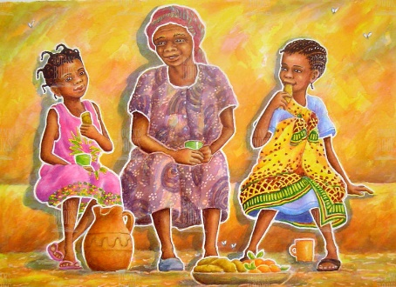

Mathematics in the Kitchen
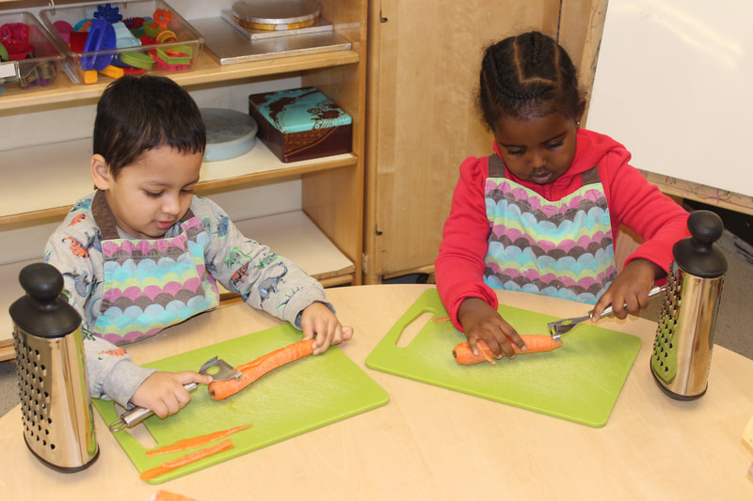
Children love to help with cooking and baking. It is great fun, and a brilliant way to talk about the mathematics together.
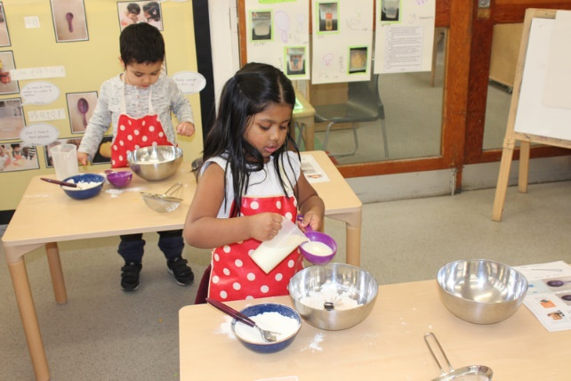
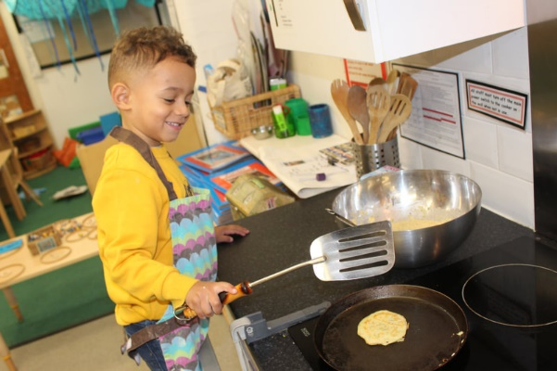
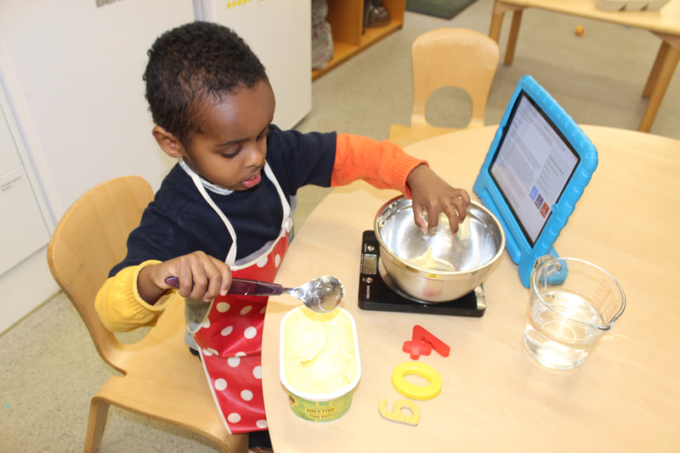
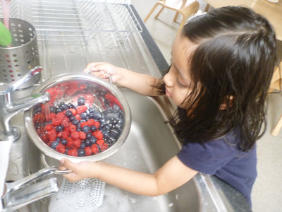
In Reception, your child will learn to:
- Count reliably with numbers from 1 to 20, place them in order and say which number is one more or one less than a given number.
- Use quantities and objects to add and subtract 2 single-digit numbers and count on or back to find the answer.
- Use everyday language to talk about size, weight, capacity, position, distance, time, and money to compare quantities and objects and to solve problems.
- Recognise, create, and describe patterns.
- Explore characteristics of everyday objects and shapes and use mathematical language to describe them.

Shape, Space and Measure
