Pancake Experts
Date: January 2020
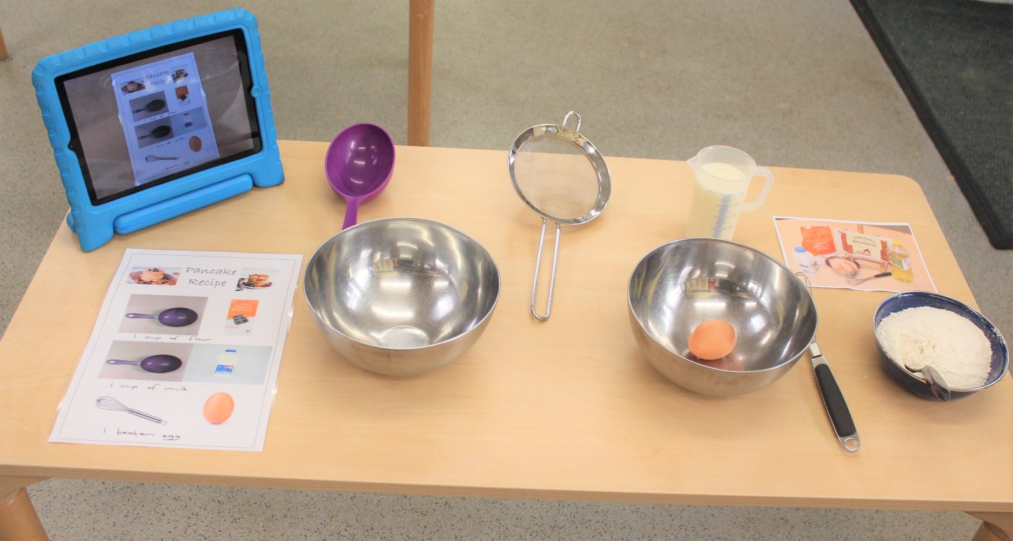
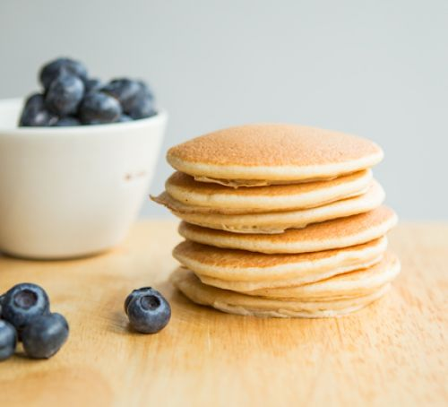
Children were supported in researching recipes: they discovered a book about pancakes from around the world. They decided to start exploring healthy pancake recipes using a variety of books and the iPad. They found recipes for apple pancakes, vegan, sugar-free, courgette pancakes and carrot cake pancakes! There’s a whole world of pancakes out there for the taking! Shoppers of the week collated lists and went shopping for the ingredients.
Across the week children were supported in measuring out the dry and wet ingredients: sometimes using cups and at other times using the digital scales. One handed tools were used to cut, chop, grate and mash ingredients and children shared their observations of the process and the changes in state of the pancakes.
You were supported to make pancakes independently: using a visual recipe and measure, mixing and cooking with minimal support.
​Watch out British Bake Off!

