Phonics: Phase 1 Family Learning Activities
Activities for children to focus on developing their speaking and listening skills; and focus on listening to the sounds around them and also begin building on their segmenting and blending skills.

Aspect 1: Environmental Sounds
Encourage your child to listen and describe what they can hear indoors and outdoors to develop their general sound discrimination.
Listening walks
- Take your child for a walk down the street, in the park or garden. Encourage your child to distinguish between different sounds – can they hear birds, cars, lorries, insects? If necessary, give some suggestions.
Listening moments  - This is a game that can be played any time and any place. Ask your child what they can hear. Can they hear the television on, or someone talking in another room, keys being pressed on a computer keyboard, a kettle boiling? | 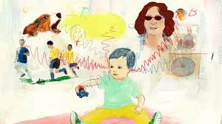
Drumming, tapping, stroking  - Give your child a wooden spoon then go outside and listen to the different sounds that can be made. What sound does a watering can make when tapped? How about the wall when the spoon scrapes along it? Which sounds can be made softly? Which ones can be played loudly? | 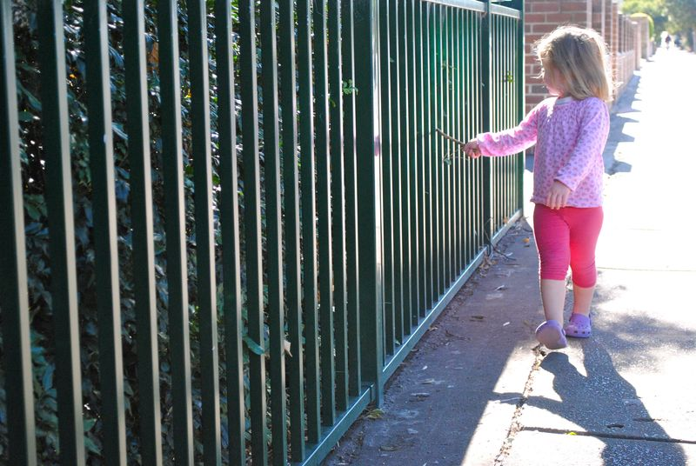
Talking about sounds  - Before you start, make sure that all bottle and packages are well sealed! Ask your child to find items in your food cupboard that can be used to make sounds. They could try rustling a packet of crisps or the wrapper of a bag of potatoes. After trying several sounds, ask them to turn their back while you repeat the sounds – can they tell you what made each sound? | 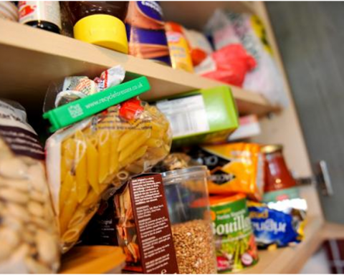

Aspect 2: Instrumental Sounds
What sounds do different instruments make? Can your child distinguish between sounds made by shakers, drums and guitar strings?
Sing, sing, sing!  - Enjoy singing nursery rhymes and songs with your child | 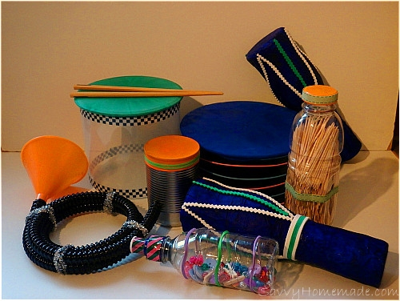
Make instruments
- Make some shakers using small plastic milk cartons containing different items such as lentils, rice, raisins, sand and small stones. Encourage your child to try each shaker, perhaps to accompany the rhythm of a nursery rhyme. Now ask them to look away while you rattle one of the shakers – can they tell which one it is?

Sound effect
- Use your home-made shakers to create sound effects for stories that you read with your child.

Aspect 3: Body Percussion
To continue their exploration of general sound discrimination, can your child perform sounds and actions such as clapping, stamping or patting their knees in time with a song or rhyme?
Action songs
- Sing nursery rhymes and songs and encourage your child to clap the beat. When they are really good at this try foot-stamping or knee-patting.
Move to the beat  - Find any piece of music that has a clear and regular beat. Use very repeating dance steps that follow the beat, encourage your child to join in. | 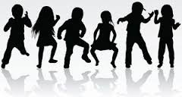

Aspect 4: Rhythm and Rhyme
Read with your child. Can they listen to and join in with a wide variety of rhymes, including nursery rhymes and rhyming books?
More book fun  - Look through the books that you have at home (or that you have borrowed from the library). Which ones feature rhyme? Book by Julia Donaldson and Nick Sharratt often use rhyme. Books such as ‘Monkey and Me’ by Emily Gravett and ‘We’re Going on a Bear Hunt’ by Michael Rosen also feature lots of repetition that your child can join in with. | 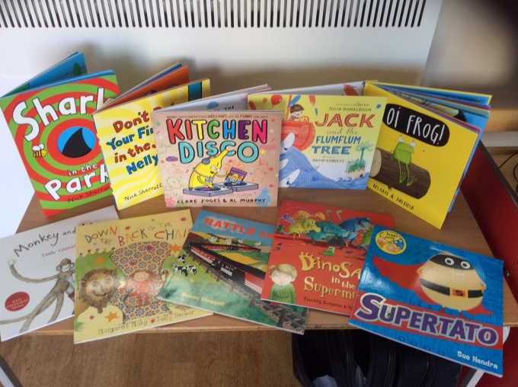

Aspect 5: Alliteration
Identifying the opening sounds of different words is a very important aid to developing the skills needed for reading. Can your child find words/objects that start with the same sound?
What’s your name?  - Use your own child’s name for making short tongue twisters: Ben’s a big boy, Molly’s made a mess. The words don’t have to make complete sense in themselves – they don’t have a form a sentence but can simply be an alliterative phrase, such as Jack’s jolly jelly. | Salma’s silly socks
Treasure hunt  - Look through the items in your house. Can you find things with the same initial letter? For example, jelly, jam, juice or milk, marmite, mint or bread, banana, biscuits. Put out two or three items with the same sound and talk about them with your child. Can your child hunt for this treasure? | 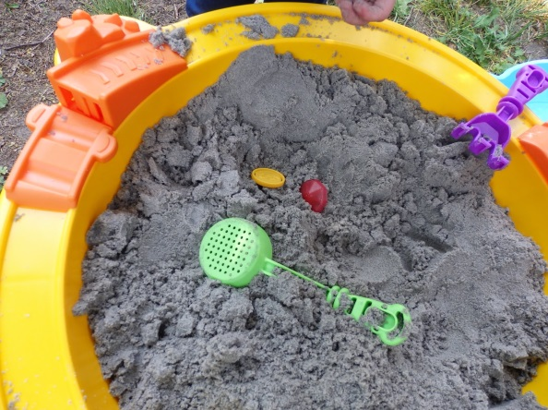

Aspect 6: Voice Sounds
Is your child aware of how many different sounds they can make with their mouths? Can they make the buzzing sound of a bee? Can they moo like a cow? Can they neigh like a horse?
Aspect 6: Voice Sounds  - Pick a favourite book that child likes to hear you read. Read the book to your child, emphasising different voices for the characters and introducing sounds wherever possible. Can your child copy the sounds? | 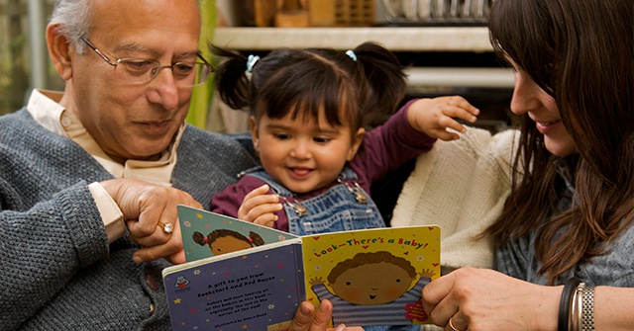

Aspect 7: Oral blending and segmenting
Helping your child to say the sounds in a word in the order they come. E.g. dog contains ‘d’ ‘o’ ‘g’.
Can you help your children say the sounds in words that contain three sounds?
Aspect 7: Oral Blending
- Show a small selection of everyday objects that contain 3 sounds. Say the sounds of one of the objects, in order, to your child and ask them to tell you what the object is.
- Adult: I spy a ‘g’ ‘oa’ ‘t’
- Child: ‘goat’ (and may pick up the item)
Aspect 7: Oral Segmenting/Blending  - Show a small selection of everyday objects that contain 3 sounds. Ask you child to choose an item and tell you the sounds, in order, and then blend after.  - Child: ‘h’ ‘or’ ‘se’, ‘mouse’  - Adult: collects the horse from the selection | 