Physical Development

Physical Development at Rachel Keeling Nursery is about the following:
- Supporting children to take measured risks.
- Developing children's understanding of the importance of physical exercise.
- Developing children's understanding about what constitutes a healthy life style.
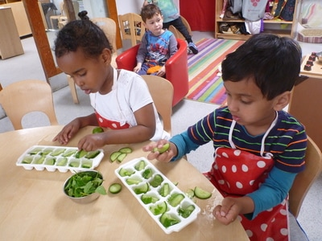
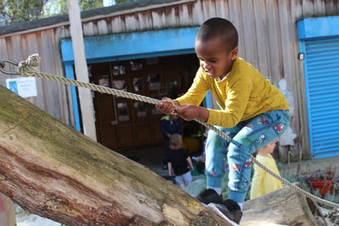
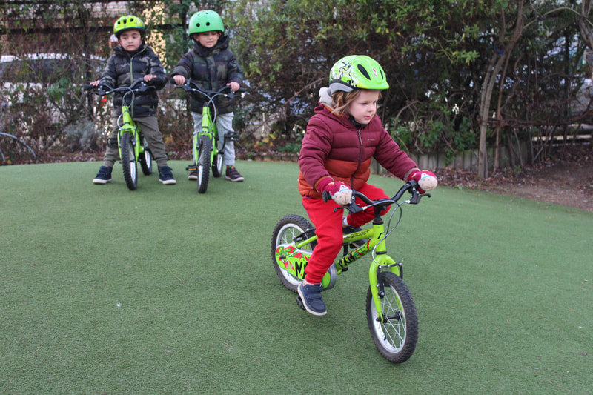
- Developing children's fine motor skills through developing large gross motor actions as well as developing dexterity through using such media as play dough and corn flour.
