Personal, Social and Emotional Development

Personal Social and Emotional Development is about the following at Rachel Keeling:
- having a sense of confidence and positive self esteem
- promoting and developing independence
- developing collaborative skills
- developing the ability to concentrate
- fostering perseverance
- developing an understanding of right and wrong
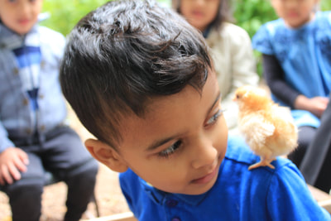
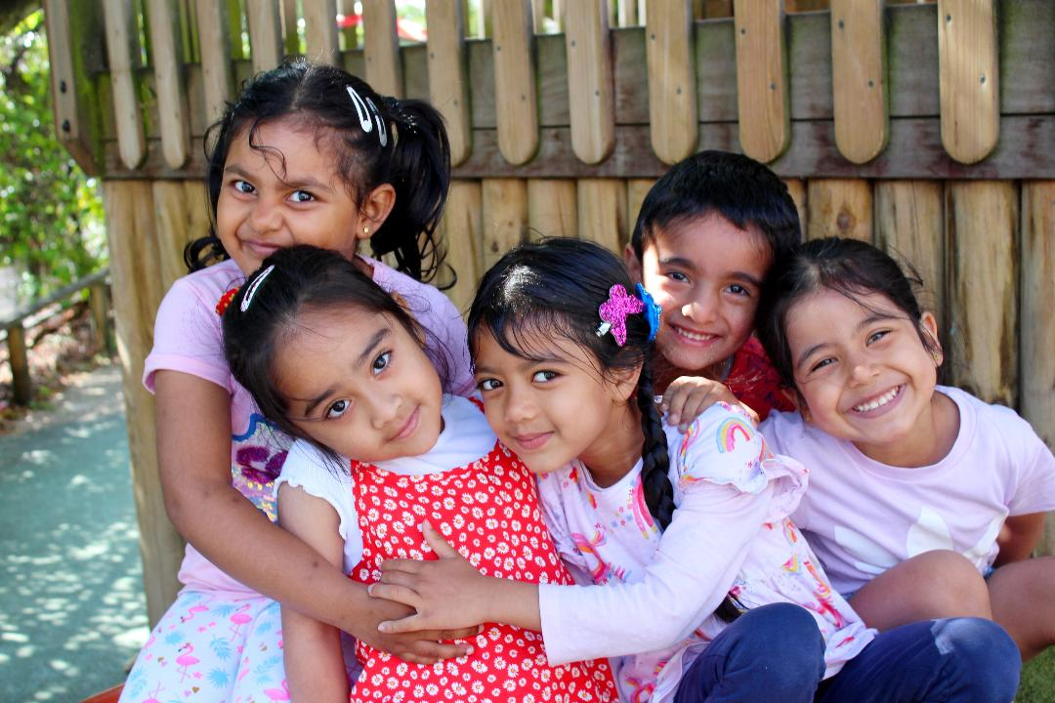
- respecting and valuing others

