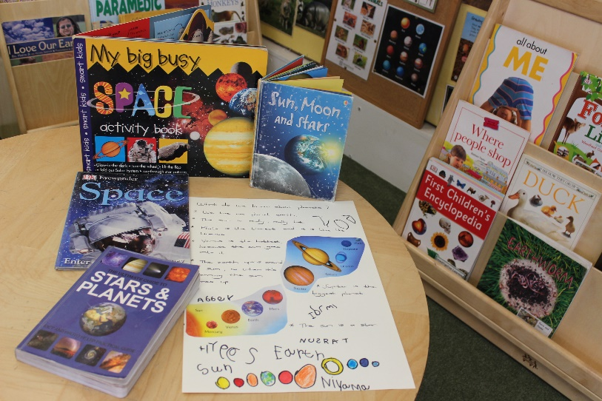
Research Library
Where children can access information books about a wide variety of subjects.
May 2019
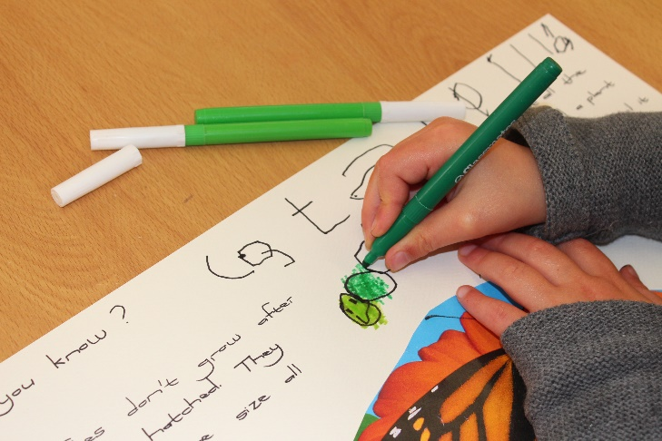
Observed by Lize
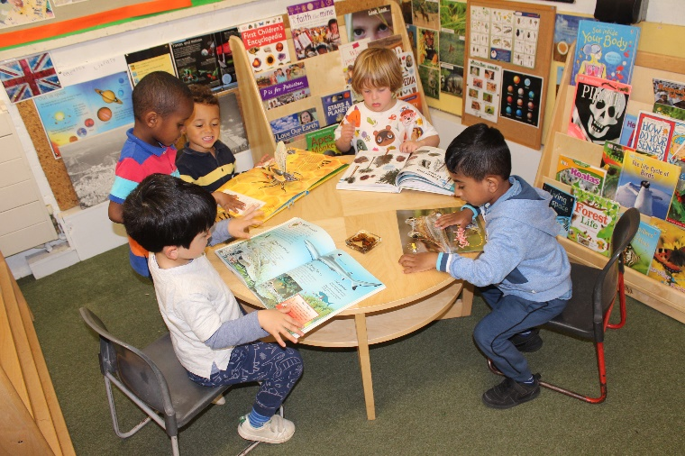
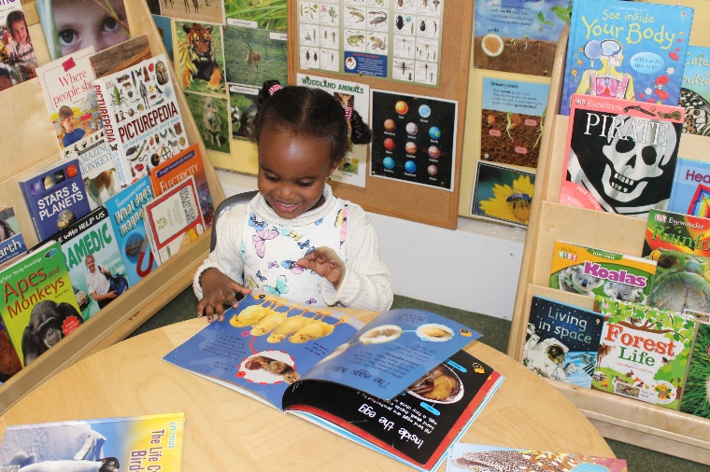
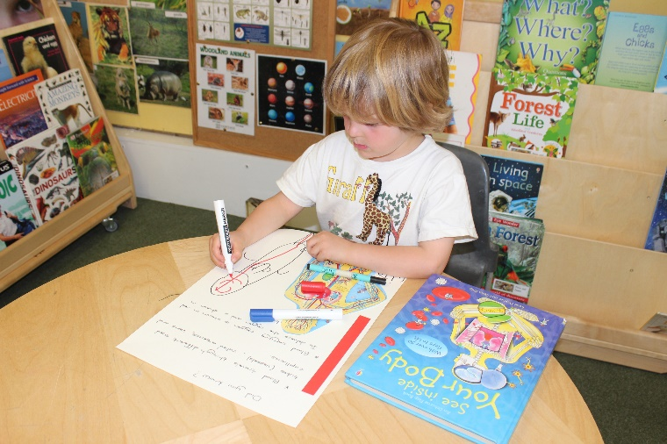
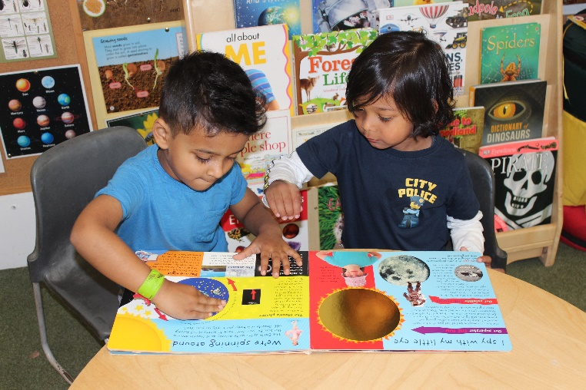
Children enjoyed sharing a range of information books to find out more about the things they are interested in. Children commented on what they know and asked questions to further develop their knowledge and understanding about a wide variety of subjects. Some children recorded their findings, ascribing meaning to their marks or writing some words phonetically. See our display in Rose Class!

