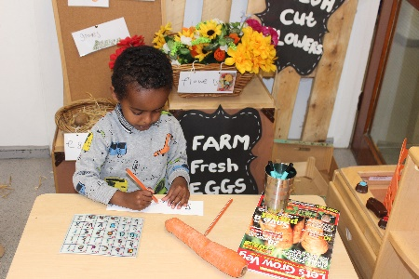  Shopping lists and labels  Children enjoyed creating shopping lists and labels for our shop area. Some children were able to form recognisable letters and use their phonic knowledge to write some phonetically plausible words.  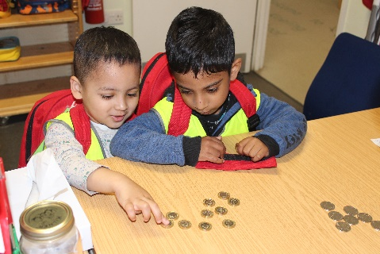  Money and Tills  Children used play money to pay for their items in the imaginative shop area. Children were able to identify the different coins and use them appropriately in their play. Some children were able to find the right coin or amount of pennies to pay for their items.  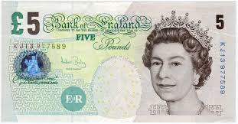  Shoppers of the week  Some children visited the local shops to purchase items for our imaginative shop corner. The children asked Pam in the office for £5 to pay for their shopping. They were able to independently put on and carry their shopping backpack to the shops. At the shops, they were able to identify the items needed from their shopping list, pay for their shopping and receive the correct change from the shop assistant. |  | We are shoppers  Children have been engaged in shopping role play this month. They shared their knowledge about shops and used a range of resources to support their imaginative play; including tills, baskets, money, a shopping trolley and real fruits and vegetables. Children also joined in with conversations about technology that is used in shops or supermarkets, such as bar codes and scanners. |  | May 2019  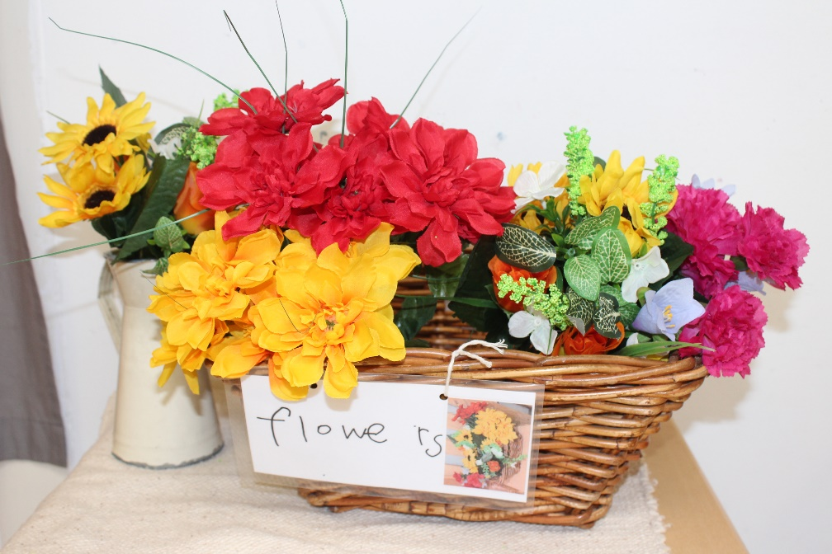  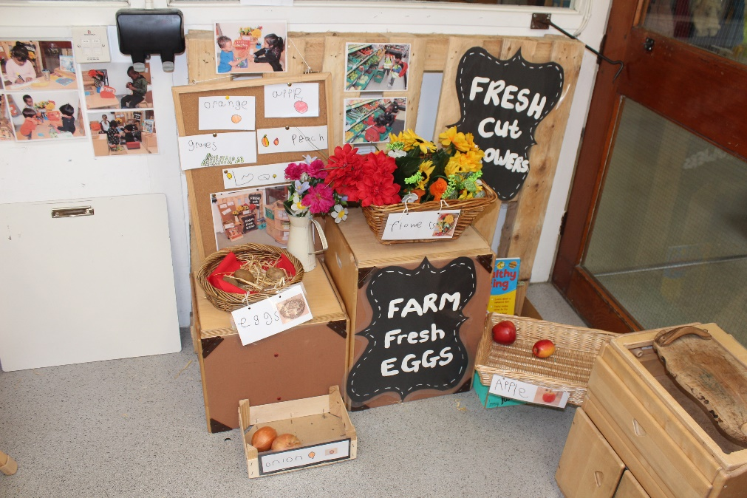  Observed by Lize and Linda  Shopping
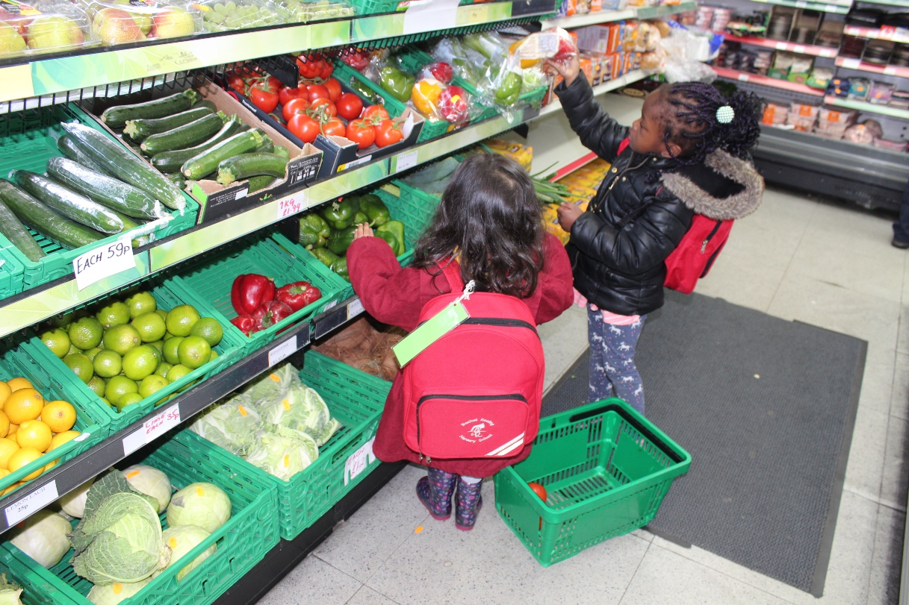
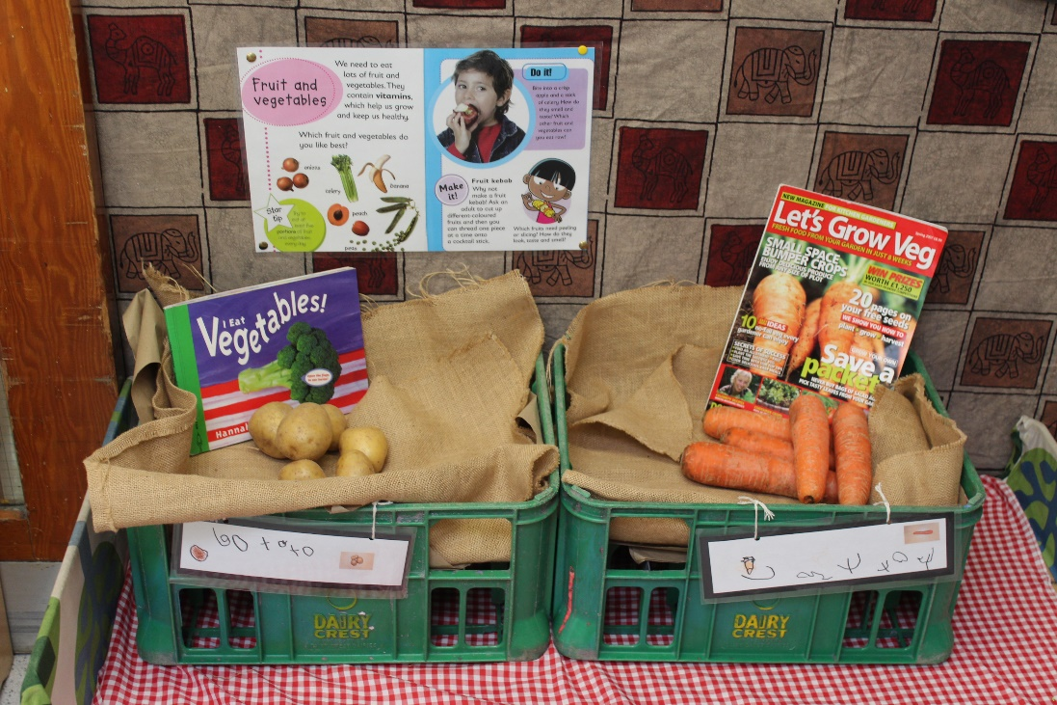
 |  |  |  | Shopping Role Play at nursery

