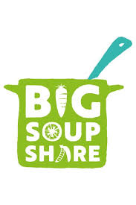
The RHS Big Soup Share
Monday 5 October - Sunday 11 October 2020
We are having our “Big Soup Share” this week at Rachel Keeling Nursery School. You have all been part of this by bringing in 1 piece of vegetable (Thank you) to make a wide variety of soups that you have thought of and researched. Also you have all taken part in the cooking process by helping with peeling, cutting, chopping, grating and cooking the soup on the hob.
You have made:
Potato and leek soup,
Mixed root vegetable soup,
Butternut squash and red pepper soup.
What other soups could you make?
We hope you manage to have a soup-er time!
