Ukulele Project at Rachel Keeling Nursery School
Our Ukulele journey Summer Term 2017
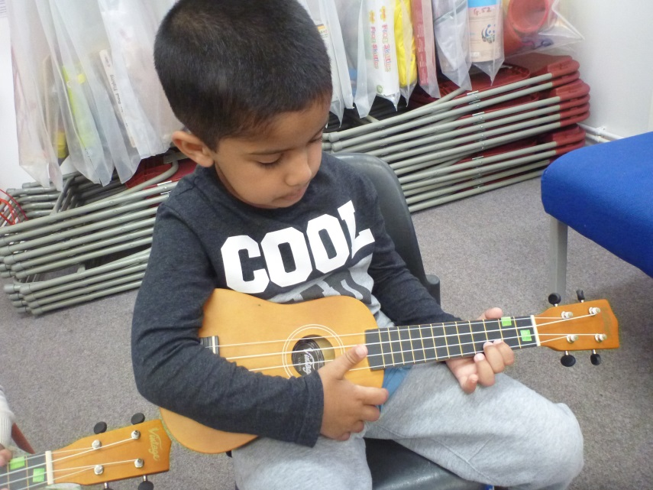
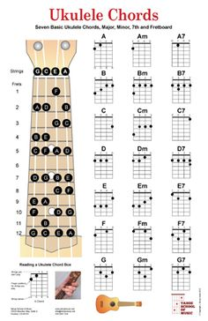
Some children have been chosen to take part in our exciting Ukulele Project this term. They showed a love for music and explored strumming, conducting, rhythm and sounds. The children have been given the opportunity to learn how to play some chords on the ukulele, using the correct techniques. Family and friends joined our whole school music session where the uke group performed Old MacDonald had a Farm.

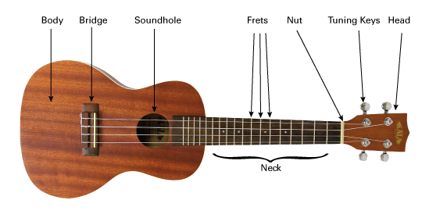

The ukulele has four strings:
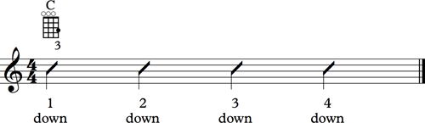

How to strum a ukulele:

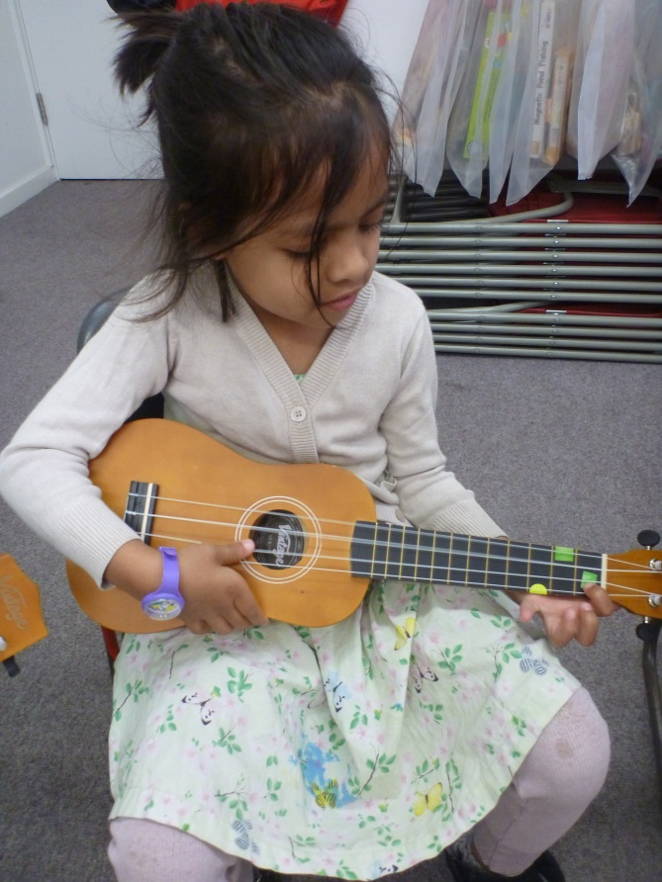

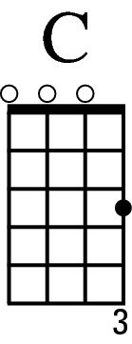
Playing the C chord:
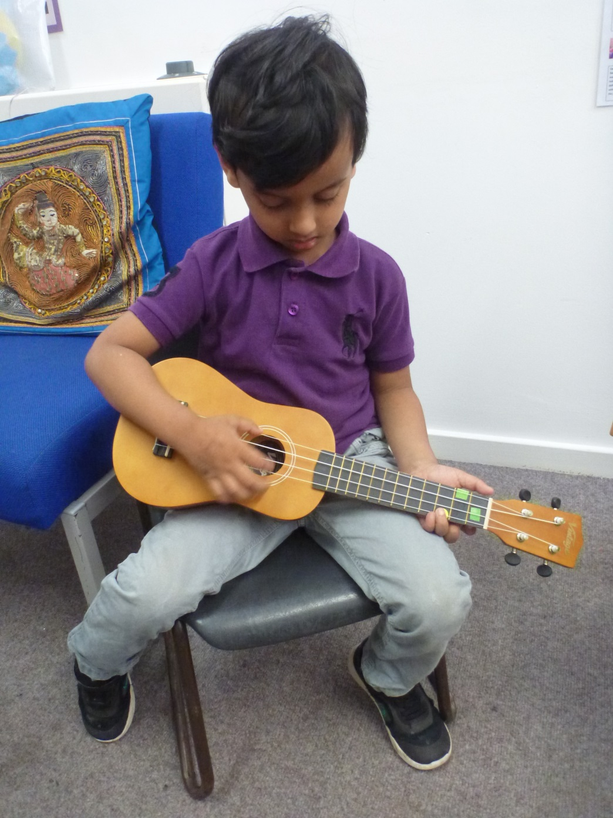

Playing the F chord:

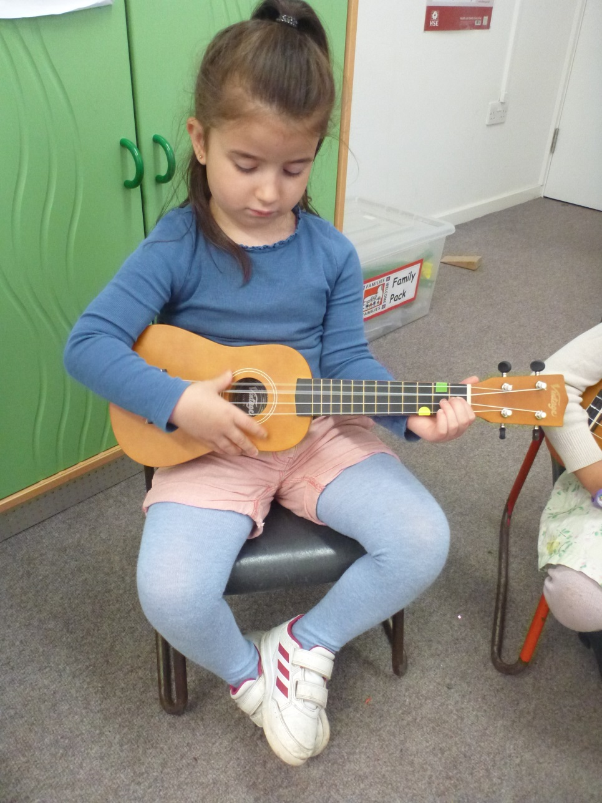
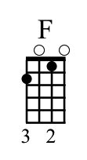

Playing Old MacDonald had a Farm
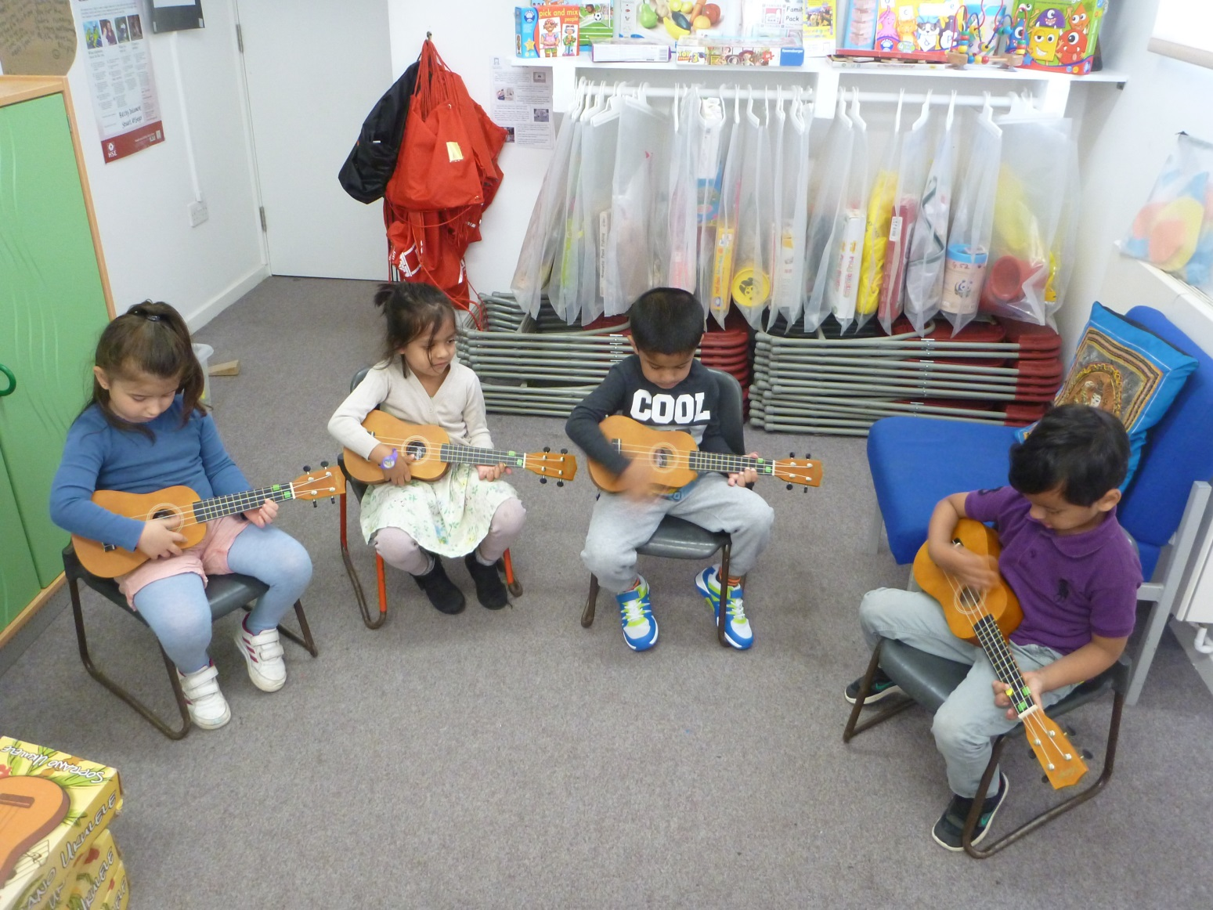

Musicians:

