**Understanding of the World**

**Understanding of the World at Rachel Keeling is about the following:**

* Fostering children's curiosity.
* Developing an understanding of planning, designing and building.
* Learning about information communication technology such as programming a simple robotic toy and printing and downloading information from a computer or Ipad.
* Having an understanding of time and place which could mean learning about such terms as a long time ago, and knowing about the local environment for example how I get to school, where the local shops are and the importance of caring for the environment.
* 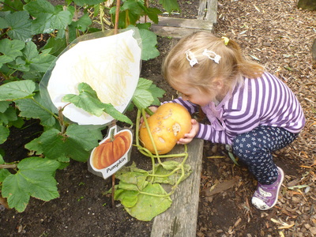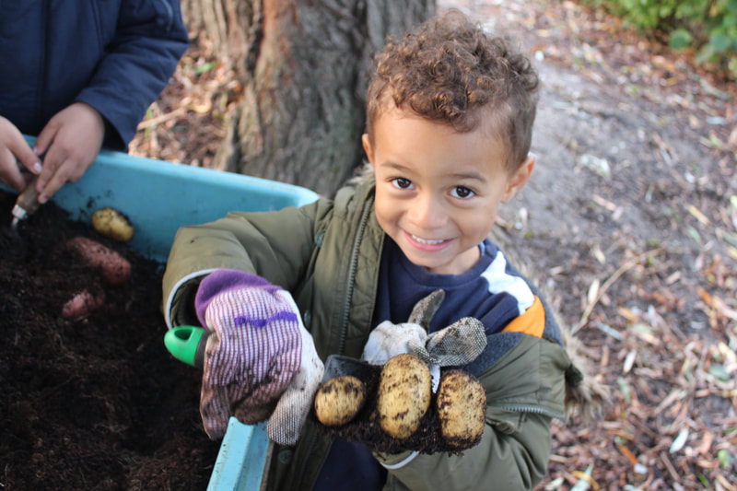Developing an understanding and respect for different faiths and cultures.

